Young People Writing: A three-year longitudinal research evaluation of The Ministry of Stories (MoS)

Final Report

The Institute of Education (IOE), University College London (UCL)

Main report authors: Dominic Wyse, Helen Bradford, Andrew Burn, Meg Wiggins

Case study report authors:

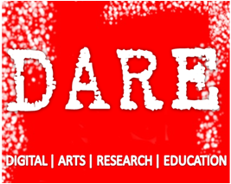
Gillian Anderson
Theo Bryer
Jane Coles
Steve Connolly
John Potter
Chris Richards

Contents

Executive Summary 4
Writing and Creativity: A brief overview of literature in the field 6
Methodology 9
Findings 11
Significant overarching changes at MoS in 2014-2015 11
Table 1: MoS Projects 2013-2015 12
Writing and Motivation to Write 16
Table 2: Scores out of 10 for perceptions of writing at the MoS and at school (10 = positive; 1= negative) 17
Table 3: YP’s reasons for differences between writing at MoS and at school (Year 3 Data) 19
Case study project synthesis 23
Summary 24
YP’s Perceptions of the MoS 25
Case study project synthesis 26
Summary 27
Reading into Writing 28
Figure 1: Darios 29
Case study project synthesis 31
Summary 31
Creativity in Writing 32
Figure 2: Creativity Progression: All case study young people 32
Table 4: Summary of creativity in writing scores 33
Figure 3: Creativity trajectories 3 year attendance 34
Figure 4: Creativity trajectories 2 year attendance 35
Table 5: Creativity of YP with one year of research data 35
Figure 5: Perry 37
Figure 6: Marlon 38
Creativity development: YP who attended for three years 39
Table 6: Marlon’s creativity development 39
Table 7: Creativity trajectories of YP who attended for three years 41
YP’s Creative Approaches to Writing 43
Figure 7: Mario 44
Figure 8: Daniel Planning for Piece A 45
Figure 9: Daniel Piece A 46
YP’s Perceptions of Creativity 47
Case study project synthesis 48
Summary 49
Expression and Communication 50
Communication and Expression within Writing 50
Figure 10: Mario Piece C 51
Figure 11: Daniel 53
Communication and Expression and the Writing Environment 54
Communication and Expression with Mentors 56
Case study project synthesis 56
Summary 57
Attainment 58
Table 8: Summary of attainment data outcomes 59
Overall level of attainment 60
Progression from year 2 to year 6 SATs 60
Attainment trajectories 60
Case study project synthesis 61
Summary 62
Conclusions and Recommendations 62
Limitations of the research 65
Recommendations for MoS 65
References 67

Executive Summary

The University College London (UCL) Institute of Education (IOE) carried out a three year longitudinal evaluation of the work of the Ministry of Stories (MoS), conducted by a team from the Digital|Arts|Research|Education group (DARE). The MoS is an organisation whose mission is to enhance the writing and creativity of young people. The MoS is based in Hoxton, London.

Writing is regarded as one of the most important aspects of learning in education. People who are unable to write at the level necessary for their future lives face serious challenges. Creativity is similarly regarded as a vital aspect of learning, although its place in formal education is variable. The research evaluation built on established theory and research in relation to writing and creativity.

The research for the evaluation was a mixed-methods design that included in-depth qualitative enquiry, a unique approach to assessing Young People’s (YP) creativity, and quasi-experimental work to measure the development of YP’s writing attainment. The research included three years’ data collection in relation to the out-of-school clubs run from the MoS premises in Hoxton, and the development of nine case studies of bespoke projects run by MoS in schools and other places during the three years of the evaluation.

The research showed overall that the work of the MoS is making an extremely important contribution to the creativity and motivation for writing of the YP it works with in London. In particular there was powerful evidence that for YP involved in the out-of-school clubs, and for many YP in the case study projects, their creativity expressed through writing was enhanced as a result of the philosophies and ways of working developed by the MoS. The research revealed consistently high motivation for writing reported by the YP as a result of the MoS approach.

Increasing levels of creativity in writing were recorded for the young people over the course of the three year period of the research. This enhanced creativity was evident not only in the traditional forms of handwritten and typed writing but also as an outcome of engagement with different media. The important influences of local community, language, and a range of popular media were noted in the research. A significant feature of the YP’s development of the originality that is a necessary aspect of creativity was seen in the changes in their processes of writing. In many cases a main emphasis on imaginative adaptation (including drawing on a range of printed and other influences they were familiar with) developed towards a main emphasis on, and greater confidence in, their own internal mental resources, without losing sight of the cultural contexts out of which the work emerged.

In addition to the many benefits for creativity and writing there were benefits more generally for the young people’s communication and expression.

Further research is needed to examine the relationships between writing attainment and the MoS approach.

A series of recommendations are put forward in this report including that the MoS should continue to seek funding to enhance its work, confident in the knowledge that it is having a powerful positive effect on YP’s creativity and writing.

Young People Writing: A three-year longitudinal research evaluation of The Ministry of Stories

The Institute of Education (IOE), University College London (UCL)

Final Report

Introduction

The overall aim of the work carried out by the IOE, reported in this document, was to undertake evaluation research (Patton, 2004) of the work of The Ministry of Stories (MoS). The MoS was directly inspired by the work in the USA of the writing centres, led by Dave Eggers, that began with Valencia 826 in San Francisco. Stimulated by work in the USA, the novelist Nick Hornby led the development of the MoS In the UK. The MoS, founded by Nick Hornby, Lucy MacNab and Ben Payne in 2010, is a creative writing and mentoring centre situated in Hoxton Street, East London for young people aged between 8 and 18 years of age. The MoS’s main aim is to unlock the creativity and develop the potential of young people to become better writers. Four core objectives underpin the ethos of the Ministry of Stories:
- to increase young people’s motivation to write and their love of writing;
- to improve their creativity in writing;
- to improve their attainment in writing;
- to improve their broader expressive and communication skills.
The MoS is supported by a team of volunteers, called ‘mentors’, who work alongside the young people who attend the clubs and support them as they write.

The MoS aims to have a positive impact on the creativity, motivation for writing, and writing development of young people from economically deprived backgrounds. Young people voluntarily attend the MoS centre in Hoxton London where they engage in a range of writing workshop activities supported by a full time workshop leader and by the volunteer mentors. In addition to the out-of-school sessions run in Hoxton Street the MoS works directly with schools and other organisations on a range of bespoke projects.

This report begins with an overview of research and theory in relation to the teaching of writing and creativity. This is followed by an account of the methodology and methods used in the longitudinal research design. Next the findings are reported in six main areas. These findings include the outcomes of the analysis of data from the final year of the research in addition to findings that take account of all three years of data. The conclusions, discussion and recommendations arising from the three years of the research are presented as the final section.

Writing and Creativity: A brief overview of literature in the field

Teaching children to be literate is one of the major goals of education worldwide (United Nations, 2014). Over the last decade evidence has accumulated nationally and internationally that pupils’ attainment in writing lags behind reading (Andrews, Wyse and Hoffman, 2010). The idea that young people who are motivated are likely to learn more effectively is both a popular idea and one backed increasingly by robust evidence. In relation to writing, there is clear research evidence that although young people start school motivated to write this motivation quickly diminishes. But there is also evidence that motivation can be maintained through the educator’s enthusiasm; the planning of thoughtful activities; setting high expectations; providing support but encouraging self-regulation; and reinforcement for the positive aspects of young people’s writing (Graham, 2010). The MoS’ approach to writing aims to enhance motivation.

The theoretical framing for the research featured in this report was derived from scholarship in two key areas: a) creativity in education, and b) the teaching of writing. Building on previous work in the field, for example a large scale research project examining creativity in the national curricula of what were the 27 nation states of the European Union (Wyse & Ferrari, 2015), the definitional constructs of originality and value theoretically framed the research, in addition to the concept of imaginative adaptation of cultural resources (Banaji & Burn, 2007; Vygotsky, 1931/1998). Originality, value and imaginative adaptation were seen as established through processes of consensual judgement, at different social levels. At the macro level such consensual judgement is reflected in the judgements made by members of academic and other social disciplines, fields and domains. At the micro level it was theorised that consensual judgement about creativity can occur between two or more people, including young people, in school and other settings. This theoretical framing built on developments in the creativity field over more than two decades in psychological, socio-cultural and educational scholarship. Seminal work that contributed to the theoretical framing included work by Teresa Amabile (1985), Mihály Csikszentmihályi (1990), Howard Gardner (1993), Lev Vygotsky (2004), and many others (see Wyse, 2015).

The theorisation of writing drew on linguistic understandings from published theory and research synthesised as a series of principles underpinning the work (a longer account addressing the origins of the theoretical influences including the linguistic principles can be found in Wyse, 2012). The centrality of meaning, aligned with an emphasis on semantics, included the understanding of metalinguistic features as labels for language rather than principal means to enhance language and literacy learning, a position consistent with the idea of descriptive rather than prescriptive grammarianism. In summary the theoretical framing of writing privileged the holistic over the partial, the social over the instrumental, the complex over the simple, the nuanced over the crudely straightforward. It recognised the socio-cultural context in which writing ‘events’ are located and focused on the creativity that emerged in the socio-cultural context.

A key area of debate with regard to writing has been the distinction between the processes of writing and the products and forms of writing. Although Graves’ (1975) original research received some criticism (e.g. Smagorinsky, 1987), there are few who doubt the influence his ideas had in practice, particularly in the United States. Graves articulated the process approach to writing, the key features of which are: generation of writing topics by pupils; regular writing workshops; the importance of redrafting and editing; ‘publishing’ in the classroom; teacher-pupil writing conferences; skills teaching in ‘mini lessons’ and embedded in one-to-one support for pupils’ writing.

If phonics has often been the catalyst to ignite debate on the teaching of reading then grammar, to a lesser intensity, has done the same for writing. Historically there was once a time when grammar teaching was the be-all and end-all of English teaching. In modern times it has been seen by some as an essential and dominant requirement to help pupils’ writing. For example the national curriculum in England includes a heavy emphasis on formal grammar teaching. Andrews et al. (2004) in their systematic review and meta-analysis, clearly showed that formal teaching of grammar to improve writing at secondary level was ineffective. They cited work by Wyse (2001) as seminal, that came to the same conclusion, that decontextualised grammar teaching is very unlikely to be beneficial at primary level.

A growing modern trend in educational research has been the focus on ‘what works’ in relation to pedagogy and outcomes for children. The teaching of grammar to support writing has been one of the subjects for investigation, as have many other aspects of writing teaching. In relation to grammar to support writing, most studies have not found a statistically significant effect for grammar teaching apart from for a particular technique called sentence combining. An evaluation of a very recent large scale rollout of an approach to grammar teaching in primary schools once again found no statistically significant evidence (Torgerson & Torgerson, 2014). However a range of approaches and strategies for the teaching of writing have been shown to be effective in systematic reviews and meta-analyses of multiple studies involving interventions compared with control groups. These include the following (from Graham, 2015):

- Use a process approach to writing (see Wyse 1998 for approach used in England)
- Encourage creativity including the use of imagery
- Encourage students to write collaboratively
- Increase the amount of writing that students do
- Establish goals for students’ writing
- Teach strategies for planning, drafting, revising and editing
- Teach transcription skills such as handwriting, typing and spelling
- Use model texts, and teach relevant vocabulary
- Use teacher assessment and peer feedback to improve writing

Another feature of transcription is the nature of the tools that are used in order to compose, or design. The new literacies movement is in part concerned with technological change. Continuing interest in multiliteracies and multimodality has prompted debate between those who see the need for greater theoretical exploration and those who argue that it is time to research what kinds of teaching, involving new technologies, is likely to support children’s learning more effectively (for different views see Jewitt & Kress, 2010, and Reinking, 2010). Our view is that new technologies are tools that still require the age-old capacities to compose text and compose visual images in order to communicate meanings that satisfy the composer and the reader. Alvermann (2008) is quite right in her argument that new technologies used by pupils at home cannot simply be ignored in school.

Furthermore, creative work in different media (comics, video, computer games), relates to print literacy. These are multimodal forms, and incorporate writing and spoken language (Burn, 2009), alongside the ‘grammar of visual design’ (Kress and van Leeuwen, 1996), the signifying properties of musical composition, and so on. In incorporating such forms into literacy programmes, it has also been shown that effective programmes build on learners’ media cultures: on their existing knowledge and expertise in film and game narrative, for example (Buckingham and Burn, 2007). In addition, recent research in multimodality has extended beyond the consideration of texts (whether print or media) to look at the importance of embodied experience: young people’s enacted narratives using dramatic expression, speech, song and dance. These are not seen as necessarily separate from text-based literacies: clearly written texts can be read aloud or performed; films incorporate bodily expression; video games include forms of virtual embodiment. These extended forms of ‘writing’ can be expected to be found in the kinds of project undertaken by MoS.

Methodology

The research objectives were to analyse the impact of the work of MoS, on the young people (YP) who had involvement with MoS, in four key areas: 1. motivation for writing; 2. writing development; 3. writing attainment in relation to statutory assessment in schools; and, 4. expression and communication. The research design was a mixed-methods, three year longitudinal study comprising qualitative enquiry and quasi experimental work on writing attainment. Two main types of research site were the locus for investigation:

a) MoS in Hoxton where voluntary attendance by YP is encouraged. 15 YP were selected (initially aged 8 to 9), through stratified random selection, from the young people attending MoS voluntarily in out of school sessions. These 15 YP were used as the basis for case studies, and for creativity assessments, and as the basis for analysis of attainment data in comparison with peers from their school class. If young people stopped attending MoS further random selection of YP was made to ensure a minimum of 15 case study YP in each year of the study.

b) Bespoke projects designed by MoS based in schools and other settings. Three bespoke projects per year of the research were selected in consultation with MoS as the basis for project case studies using the same focus areas, and broadly similar methods as the longitudinal design apart from statistical analyses of attainment data. Case studies of projects typically included attendance at a minimum of four full workshop sessions by members of the research team to document their observations in field notes.

Data Sources

The data sets for the longitudinal analyses of young people (selected as case studies) at after school clubs and Saturday mornings included the following: a) recorded and transcribed interviews with young people (n=60+); b) portfolios of YP’s writing (n=45); c) creativity assessments based on consensual judgements of YP’s writing using a creativity assessment tool designed for the project (n=90); d) field notes from observations of workshop sessions (n=15+); e) statistical analyses of a sample of YP involved in MoS (n=25) in relation to their statutory test scores compared with their school class peers (n=106). These data, and their analyses, were accumulated once per year for three years. Baseline data included interviews with YP at the start of their involvement in the research, and attainment data which included test data prior to their involvement in MoS.

The MoS permanent workshop leader and a research associate carried out all the creativity assessments and their initial analyses. A process of consensual judgement was undertaken for samples of writing from each of the 15 case study YP each year. The consensual judgements recorded (taking account of the processes the YP engaged in during the writing) the extent to which creativity was demonstrated: very weakly; moderately; strongly; or very strongly in relation to the following six criteria: a) The sample of writing demonstrates imaginative adaptation of existing ideas; b) The process of writing demonstrated imaginative adaptation of existing ideas; c) The sample of writing demonstrates originality; d) The process of writing demonstrated originality; e) The sample of writing demonstrates value. f) The process of writing demonstrated value

Data analyses consisted of a range of qualitative data analysis and quantitative data analysis methods. Interview transcripts, examples of YP’s writing, and field notes from observations were imported to NVivo qualitative data analysis software and subject to coding in the following first level codes: Motivation to write; YP’s perceptions of writing and the MoS; Influence of reading on writing; Creativity in writing; Expression and communication. Sub-codes were extended from first level codes. Examples of sub level codes included: control and choice over writing; composition of writing vs. transcription of writing; the nature of different levels of creativity; the influence of books and other media on writing; etc.

Statistical analyses of attainment data compared 15 case study YP with 106 of their school class peers, not involved in MoS, in order to determine writing attainment trajectories in relation to three attainment bands: low; medium and high attainment. Standard data cleaning, tests for homogeneity of intervention and control YP, cross-tab analyses and p-value tests of statistical significance were undertaken.

Case study reports from bespoke projects were compared holistically with findings from the longitudinal elements to augment and enrich the findings in the writing of the annual reports.

The research was subject to the institutional ethics procedures of the Institute of Education (IOE: at the time a university in its own right, and an institution in existence for more than 100 years. Subsequently merged with University College London (UCL) as a school and faculty of that university). The research also conformed to the ethical code of the British Educational Research Association. The ethical policy of the evaluation specifies anonymity of the participants: all young people in this report are accordingly represented by pseudonyms.

Findings

Significant overarching changes at MoS in 2014-2015

One of the most important variables in improving educational outcomes in all areas of education is the people involved. The leaders, the teachers, the mentors, the learners are the most significant factors in educational change. For that reason any changes in personnel in relation to a programme and/or intervention are always significant. This year saw a return from maternity leave of one of the Co-Directors of MoS, and a change in Creative Learning Manager. Additionally, although this is unlikely to have influenced the findings of the work this year, the current Writing Programme Leader left in early September to go freelance.

With regard to the young people (YP) selected as case study YP, five out of 15 of the original research sample selected in year one were still attending the out-of-school clubs on a regular basis; the attendance of a further one YP was sporadic this year, however it was possible to collect a full set of data for her, giving a total of six original participants who attended all three years of the research. Through the process of stratified random selection six new participants joined the study in year two, four of whom remained for the final year of the study, giving two years’ worth of data for these YP. For the final year of the study, an additional set of baseline interviews was conducted with seven new participants in December 2014, of whom five remained at MoS at the last point of data collection in June and July 2015. This gave a total of 15 participants for Year 3.

The breadth of data analysed overall was complemented by data from the six YP who remained at MoS for the entirety of the project, providing greater depth of analysis and an important longitudinal dimension to the study. This analysis was also able to benefit from the experience of some YP interviewed during Year 3 who had been attending the writing clubs for the three year research period but who had not been selected as case study YP in year one or year two. Their reflective comments were analysed alongside those of the original six YP who had been selected as case study YP in Year 1.

Research evaluation methodology that is focused on interventions typically relies on educational programmes that are stable over the time of the evaluation. However in the real world of programmes and interventions to enhance YP’s learning, programme stability is not always the most appropriate state because incremental improvements in practice need to be made. In this final year of the evaluation one significant change to the work of the workshops was a change in focus in terms of writing output. Over the last two terms of the year, MoS was preparing for their conference Write for A Bright Future involving delegates from around the world involved in similar writing out-of-school writing clubs. This saw the YP from the MoS Thursday and Saturday writing groups, in particular, developing materials for the conference, for example London guides for the delegate conference pack. The Wednesday group created a radio podcast based on their experiences of being in their final year of primary school and their feelings as they approached Year 7. This kind of collaborative goal-oriented way of working can have significant advantages, but at the same time it means that the more regular ways of working that we have documented over this three year period changed for these groups.

At the time of the data collection period, one main issue that was both observed and discussed with the WPL was the status of the Wednesday after school club. Over the past three years the club was not repopulated with new YP as participants left. The culmination of such an approach of natural wastage left only 11 participants in this final year, yet mentor numbers remained at the level they had been throughout. For example on one observed session there were 10 participants and five mentors plus the WPL. A group of 4 or 5 YP dominated this group, and collaborated less with the whole group, hence affecting group dynamics. Some also changed their minds in relation to their willingness to interact with mentors. Two YP’s comments in their final interviews were about not wanting the mentors to be involved with them during sessions. One of the members of this group was consistently the strongest writer over the entirety of the project, yet her scores in relation to enjoyment of writing both at MoS and at school significantly dipped this year.

One of the many important issues for the context of the MoS and this evaluation is the relationships between MoS and formal education in schools. These relationships include: expectations of teachers and MoS staff; pedagogy of approach to writing in the MoS and in school; recognition of prior learning and ‘feed-in’ to future learning progression; and philosophies of working with young people in education and in the MoS. For this third year of the evaluation the YPs age meant that they undertook their national statutory assessments (commonly known as SATs) in May 2015. For English this involved two papers with a focus on grammar, punctuation and spelling. Paper 1 comprised 40 to 50 short-answer questions covering grammar, punctuation and vocabulary, taking 45 minutes; Paper 2 was a spelling test with 20 questions, taking approximately 15 minutes. Six YP referred to their SATs in their final interviews, making a total of nine comments between them. Over the three year period of the study YP have consistently made positive comments about the impact of attendance at MoS writing clubs in relation to writing levels in school.

Although the overarching changes outlined above are significant, they have to be seen against the backdrop of the features of MoS that have been consistent over the three years. The most important of these is the philosophy of developing children’s writing by developing their creativity. The other consistent feature is the use of creative approaches to pedagogy in order to enhance writing. Voluntary attendance by young people is a key feature of the out-of-school clubs which contrasts to some degree with the more formally organised projects that we feature in the nine case study bespoke project (see appendices for the case studies carried out 2014 to 15). Voluntary attendance by mentors and the need for support from MoS staff as the mentors seek to support the YP is another fundamental feature of the work of MoS. And finally the physical environment of the MoS space in Hoxton is also an important feature of the MoS approach.

The projects that MoS carried out in year three can be seen at the end of Table 1 which shows all the activities that were part of the research evaluation across the three years of the study.

Table 1: MoS Projects 2013-2015

Name of Project | Dates (2012-2013) | Group type | Age range
Storymaking workshop | Various - every Wednesday in term time. During September and October there were three per week. | School Class of up to 30 | 8 to 11
Comic book workshop | Various - about one every two weeks during term time, starting in February | Seconday class (but only up to 20 people in each session) | 11 to 14
After school clubs - Song writing (Thursdays and Saturdays) and Writing for Radio (Wednesdays) | Various - every Wednesday in term time at Randal Cremer Primary school. Every term time Thursday and Saturday at the Ministry of Stories. | In Randal Cremer, up to 25 Year 4 pupils. At Ministry of Stories, children who live or go to school within a 500m radius. | 8 to 12
The Global Children's Postal Service | November 6th to December 18th, every Tuesday | Two Year 5 classes from St John the Baptist school, who arrived separately for their respective workshops, one in the morning and one in the afternoon. | 9 to 10
After school club for Secondary students. Comedy Script Writing | January 8th to July 9th, every Tuesday evening | Secondary students who live or go to school in Hackney, Tower Hamlets, Islington and the City of London | 12 to 16
Storymaking and memories | 15th and 22nd January | An ASDAN class from the Bridge Academy | 14 to 16
Comedy script writing (schools) | 30th January to 27th February, once a week in term time | Year 10 group from the City Academy, Hackney made up of top set pupils and bottom set pupils | 14 to 15
Global Children's Postal Service | 26th February to 26th March, once a week | Year 5 class from Burbage Primary School | 9 to 10
Soap opera script writing | 4th March to 25th April | A community youth club (Fellows Court) group meeting on Monday evenings | 16 to 19
Holiday club - Planting Poetry | 2nd April to 6th April | Children who live or go to school within a 500m radius. Sessions were half a day long and a celebration event was held on 20th April. | 8 to 12
Bottled Emotions | 16th April to 21st April | A Year 7 class at the Bridge Academy | 11 to 12
World Book Day event | 7th March | A whole school event at the Bridge Academy, that MoS delivered a small part of throughout the day (delivering workshops to Year 7 classes) | 11 to 12
What's in that shed? | June 3rd to June 28th. Full days' workshop on Tuesday of each week and a half day on Mondays of each week. A celebration lunch time event was held on the 28th. | A New Horizon group from the Hackney Community College. The students had high learning needs. | 16 - 21
Breaking Bread - holiday project | July 29th to August 2nd, full day workshops. | Children who live or go to school within a 500m radius. A sharing event was held on 17th August. | 8 to 12
Computer games and stories - holiday project | August 13th to 23rd, full day workshops. | Children from Islington, Tower Hamlets, Hackney and the City of London (although many of them can from our more local clubs and live very near us) | 11 to 14

Name of Project | Dates (2013-2014) | Group type | Age range
Storymaking workshop | Various - every other Wednesday in term time. | School Class of up to 30 | 8 to 11
Comic book workshop | Various - about one every two weeks during term time. | Secondary class of up to 30 | 11 to 14
After school clubs –  Speech Writing, ‘The Island’ project and Theatre Script Writing (Thursdays and Saturdays).  Free writing for audio recordings and Theatre Script Writing (Wednesdays) | Various - every Wednesday in term time at Randal Cremer Primary school. Every term time Thursday and Saturday at the Ministry of Stories. | On Thursdays and Saturdays, at the Ministry of Stories, children who live or go to school within a 500m radius.  In Randal Cremer Primary School on Wednesdays, up to 25 Year 5 pupils. | 8 to 12
The Global Children's Postal Service | September 10th to 22nd October, weekly every Tuesday. | A Year 5 class from Whitmore Primary school. | 9 to 10
Make a Museum – a project that invented a fictional museum and asked children to fill it with memories and voices through their writing. | January 14th to 24th January, 8 workshops and two assemblies. | All Key Stage 2 classes: Year 3, Year 4, Year 5 and Year 6. | 7 to 11
Bottled Emotions | 10th January to 14th February, once a week on Fridays. | A Year 7 class from the City Academy. | 11 to 12
Speech Writing and delivery | 24th February to 31st March, once a week on Mondays. | A Year 8 literacy intervention group of 6. | 12 to 13
Comedy Script Writing | 13th November to 18th December, once a week on Wednesdays. | Year 12 and 13 group from the Petchey Academy. | 16 to 18
Planting Poetry (a mesostic poetry project which ends with the installation of signs bearing this poetry in a local garden) | 24th April to 22nd May, with a sharing on 12th June. | A Year 5 class from William Pattern Primary School. | 9 to 10
Writing about Wildness (exploring a natural space and writing and delivering performance poetry within the site). | 6th June to 20th June, weekly on Fridays. | A Year 7 class at the Raines Foundation School. | 11 to 12
Family Programme (a series of open house events/workshops aimed at engaging local families in MoS’ work) | The first Saturday of each month. | Local families, some with children who attend our after school clubs and some who do not. | All ages
A Guide to Hoxton (writing a guide to the local area). | 7th April to 11th April, 5 full days. | Local children, some of whom are club members and some who were new to MoS. | 8 to 12
Face time: portraiture in writing and in drawing (a collaboration with the Princes Drawing School) | 11th August to 15th August, 5 full days. | 30 participants. 15 recruited by the Princes Drawing School and 15 recruited by MoS (we sourced our participants from our after school writing clubs and from local schools). | 10 to 15
Speech and Manifesto Writing with Hackney Youth Parliament | 4th August to 11th August, 5 half days. | Up to 15 11 to 19 year old residents of Hackney. Candidates for the Hackney Youth Parliament were particularly targeted. | 11 to 19
Gardening, eating and writing with Skyway at the Blue Hut. | July 28th to July 30th, 3 full days. | Members of the Provost Street Estate, recruited by Skyway who run the Blue Hut Youth Centre. | 11 to 14

Name of Project | Dates (2014-2015) | Group type | Age range
Storymaking workshop | Various - every other Wednesday in term time. | School Class of up to 30 | 8 to 11
Comic book workshop | Various - about one every two weeks during term time. | Secondary class of up to 30 | 11 to 14
After school clubs –  Self-directed ‘free’ project (children chose their own writing activity); Write For A Bright Future | Various - every Wednesday in term time at Randal Cremer Primary school. Every Tuesday term time at St John the Baptist church. Every term time Thursday and Saturday at the Ministry of Stories. | On Tuesdays, Thursdays and Saturdays, at the Ministry of Stories, children who live or go to school within a 500m radius. | 8 to 12
Podcast/ Audio Project ‘That’s Just Us’. | Ongoing, weekly. The club has existed for 3 years, with members staying each year. | In Randal Cremer Primary School on Wednesdays. Group of 9 regular students in year 6. | 10-11
Three Bags Full – Fiction Writing ‘Late Night Tales’ | 13th April to 13th May, weekly sessions at school with visit to MoS at start and end. | Large schools group of 2 combined classes, total 28 students. | 13-14
Poetry to Go – exploring poetry, forms, rhythm, playing with language, trip to Saison Poetry Library, writing for food sellers on Hoxton Street, writing for the public in a poetry van. | 7th April to 11th April, Daily sessions at MoS | Children recruited from the three out of school clubs, local primary schools and via the shop (poster). 16 in total. | 8-10
Comedy Script Writing- understanding comedy, crafting characters and scenarios, creating a film script.  Comedy Script Writing(2) understanding comedy, crafting characters and scenarios, creating a film script. | 29th March-4th April, daily sessions at MoS.  2nd June- 7th July 2015 | Graduates from our writing clubs.  In partnership with Hoxton Hall, weekly sessions for older teenagers. | 12-14  15-18
Family Programme (a series of open house events/workshops aimed at engaging local families in MoS’ work) | July to August 2015: engaging with Skyway, inviting local parents to a Q&A, hosting open day. | Local families, some with children who attend our after school clubs and some who do not. | All ages
Storyengine | September to February  Workshops forming part of digital research project exploring the potential for technology to enhance, extend or complement the MoS learning model. | Langley Park School for Boys, Kent  Harris Girls Academy, London  Morpeth School, London  Hove Park, Brighton  UCL Academy, London  Wickersley School, Rotherham | 11-12

Writing and Motivation to Write

A quick overview of the YP’s motivation for writing was seen in the scores out of ten that they allocated to the final questions in the interviews (see Table 2). It was clear that the young people were highly motivated to write by the MoS. However it is important to note that the majority of young people began their experience at MoS indicating that they were highly motivated, and ended the three years of the evaluation still highly motivated. Within these overall patterns there were also fluctuations for some young people that were indicative of more profound qualitative changes in their attitudes: we pick these up as appropriate in later sections of the report.

Further analysis of the reasons for the scores was carried out (Table 3). Only one YP, Janica, gave both 10/10 for writing at MoS and at school. Looking into her final interview responses further, Janica talked about the impact of attending MoS on helping her to write successfully at school which is perhaps why she gave both the same high score. Other YP also gave relatively high scores to writing in school. Of those who gave school 8/10 and above compared with 9/10 and 10/10 for MoS the common use of particular words and phrases amongst the YP to describe the school context was significant: “force” [to do writing] was used twice and “strict” once. Lower scores for school (7/10 and below) also included “force”, and “boring” was used twice to describe the school context. Another YP (Eloise) used the descriptive phrases “really stressful” and “under pressure” in one sentence to describe writing at school. In direct contrast, descriptive language used in relation to writing enjoyment at MoS emphasised the choice and freedom that the YP felt when they participated in sessions, for example “funness”, “free”, “a bigger opportunity to express what’s in your head”.

[blank space]

Table 2: Scores out of 10 for perceptions of writing at the MoS and at school (10 = positive; 1= negative)

 | WvL | MoS | S | SG | WvL | MoS | S | SG | WvL | MoS | S | SG | WvL | MoS | S | SG | WvL | MoS | S | SG | WvL | MoS | S | SG
 | Baseline |  |  |  | Y1 End |  |  |  | Baseline Y2 NS |  |  |  | Y2 End |  |  |  | Baseline Y3 NS |  |  |  | Y3 End
Marlon | 10 | 10 | 10 | 10 |  |  |  |  |  |  |  |  | 10 | 10 | 8 | 5 |  |  |  |  | 10 | 9 | 8 | 9
Edith |  |  |  |  |  |  |  |  |  |  |  |  |  |  |  |  | 10 | 10 | 4 | 9 | 10 | 10 | 5 | 8
Janica |  |  |  |  |  |  |  |  |  |  |  |  |  |  |  |  | 10 | 10 | 9 | 10 | 10 | 10 | 10 | 10
Elizabeth | 10 | 10 | 9 | 10 | 10 | 9 | 10 | 7 |  |  |  |  | 10 | 10 | 9.5 | 10 |  |  |  |  | 10 | 9 | 0 | 7
Julie | 10 | 10 | 10 | 10 | 10 | 10 | 9 | 10 |  |  |  |  | 7 | 10 | 4 | 9
Perry |  |  |  |  |  |  |  |  | 10 | 10 | 0 | 10 | 10 | 7 | 8 | 10 |  |  |  |  | 10 | 10 | 9 | 10
Chidimma | 10 | 9 | 10 | 8
Peter | 5 | 5 | 5 | 2 | 7 | 10 | 6 | 7 |  |  |  |  | 10 | 9.5 | 4 | 5
Mario | 10 | 8 | 3 | 1 | 9 | 10 | 7 | 9 |  |  |  |  | 10 | 8 | 5 | 7 |  |  |  |  | 10 | 9 | 7 | 6
Jonathan |  |  |  |  |  |  |  |  | 10 | 10 | 4 | 10 | 10 | 10 | 10 | 7 |  |  |  |  | 10 | 10 | 9 | 7
Daniel | 7 | 10 | 5 | 10 | 7 | 10 | 9 | 9 |  |  |  |  | 10 | 10 | 10 | 7 |  |  |  |  | 9 | 10 | 8 | 9
Efthalia |  |  |  |  |  |  |  |  | 10 | 9 | 8 | 10
Christabella | 10 | 10 | 10 | 10 | 9 | 9 | 10 | 9 |  |  |  |  | 10 | 10 | 9 | 10 | 10 | 10 | 5 | 10
Adeto | 10 | 10 | 8 | 9
Jake | 10 | 10 | 10 | 10 | 10 | 10 | 7 | 10
Pearl |  |  |  |  |  |  |  |  | 9 | 10 | 5 | 8
Chinedu | 9 | 10 | 8 | 9
John | n/a | 10 | 9 | 10 | 10 | 10 | 9 | 10 |  |  |  |  | 10 | 9 | 5 | 8
Abdul | 10 | 8 | 8 | 10 | 10 | 10 | 10 | 10
Irene | 4 | 5 | 10 | 10 | 6 | 6 | 10 | 10
Robert |  |  |  |  |  |  |  |  |  |  |  |  |  |  |  |  | 9.5 | 9.5 | 8 | 10 | 10 | 10 | 9.5 | 10
Eloise | 10 | 10 | 9 | 10 | 10 | 10 | 10 | 10 |  |  |  |  | 10 | 10 | 3 | 7 |  |  |  |  | 10 | 6 | 5 | 7
Jemima |  |  |  |  |  |  |  |  | 10 | 9 | 3 | 8 | 10 | 7 | 7 | 5 |  |  |  |  | 10 | 9 | 7 | 9
Celine |  |  |  |  |  |  |  |  |  |  |  |  |  |  |  |  | 10 | 10 | 10 | 10 | 10 | 10 | 8 | 10
Jamal |  |  |  |  |  |  |  |  | 10 | 10 | 7 | 8 | 9.5 | 8.5 | 7 | 8.5 | 10 | 9.5 | 6 | 7.5
Niles | 9 | 10 | 10 | 6 | 10 | 9 | 9 | 10
Albert | 10 | 10 | 10 | 10
Nate | 10 | 10 | 10 | 10 | 10 | 10 | 10 | 9
Christabella |  |  |  |  |  |  |  |  | 10 | 10 | 9 | 9
Susannah |  |  |  |  |  |  |  |  | 10 | 10 | 9 | 9 | 7 | 10 | 9 | 10
Tameda |  |  |  |  |  |  |  |  | 10 | 10 | 10 | 10 | 10 | 10 | 10 | 8
Jean Paul |  |  |  |  |  |  |  |  |  |  |  |  |  |  |  |  | 10 | 10 | 7 | 8
Darios |  |  |  |  |  |  |  |  |  |  |  |  |  |  |  |  | 10 | 10 | 7 | 9 | 8 | 7 | 3 | 8
Key: | WvL= Writing compared to Favourite thing in Life; MoS = Writing at MoS; S=Writing at School; SG=School in General
 | Grey cells=no interview (because baseline interview done only once, or YP not attending in year of interview)

Table 3: YP’s reasons for differences between writing at MoS and at school (Year 3 Data)

Young Person | Writing at MoS | Writing at School | Reason
Marlon | 9 | 8 | They [MoS] don’t like, they...they like, they [school] force you to write something, you have no choice but to do it.
Edith | 10 | 5 | Main difference is because ... say zero, but I’ll say five because it actually helps you, school writing, but I think it’s really boring in class, just missing that funness that Ministry of Stories has.
Janica | 10 | 10 | R: Is there a difference between the writing you do at school and the writing that you do at Ministry of Stories?  A: No.
Elizabeth | 10 | 0 | And at school they force us to write, like...well not really forcing...yeah, forcing, because they are not allowed to write for us, and if we are like feeling sick they don’t want to hear what we say, they just want to know what they say, and they give us something to write about. But in the Ministry of Stories they don’t really give us something to write about, we can write about what we want.
Perry | 10 | 9 | In school we do like we are supposed to do like two and a half pages but in the Ministry of Stories you can do how many pages you want, and they don’t force you to, and in school they do really force you.
Mario | 9 | 7 | It’s more quieter [sic], at school teachers will be telling off people and stuff.
Jonathan | 10 | 9 | Just because I just don’t want to rewrite again and again.
Daniel | 10 | 8 | Because usually at school they are kind of like quite, a little bit more strict, rather than Ministry of Stories.
Robert | 10 | 9.5 | Well you are free, you can write what you want, unless it’s, you know, about the topic, but no one is telling oh no you can’t do this, you can’t do that, they don’t do that, they don’t tell you what to do, they just let you do what you want to do and help you.
Eloise | 6 | 5 | Because when you are writing in school it’s really stressful, because it’s like you get put under pressure, and in Ministry of Stories sometimes it feels annoying when the mentor keep coming around to ask what you are doing, and when you don’t really feel comfortable when they are doing that, and you try to tell them to stop but you don’t want to hurt their feelings, because then they are just distracting you and you won’t be able to finish your work.
Jemima | 9 | 7 | I can’t concentrate fully because people will talk about other things other than writing their stories, so sometimes I get sucked into the conversation.
Celine | 10 | 8 | Because the work at school’s slightly harder.
Darios | 7 | 3 | “…writing club’s more relaxed [than school]…I write better independent and relaxed.”

For the YP who attended the out-of-school writing clubs this year, motivation to write centred on three themes. The first of these themes was improvement of writing. The six case study YP all reflected on why they first joined MoS when they were in Year 4. This was often the desire to improve their writing ability through participation at the MoS. In subsequent years of attendance these six young people reported improved school performance in writing. All 15 YP categorically stated that attendance at MoS sessions positively impacted writing at school. Typical responses centred on the YP’s increased national curriculum levels at school for example.

The second theme in relation to motivation to write to emerge was freedom. Participation at MoS enabled the YP to respond and develop a particular writing activity in their own way and thus opened the space for creativity (as opposed to prescribed learning objectives in school which may dictate how writing outcomes are shaped). All 15 YP contrasted the writing environment of MoS with that of school, (also reflected in table 3) giving further insight into this phenomenon. The environment for writing the YP encountered at MoS also continued to be significant for the YP in relation to motivation. Responses centred on the value of talk during the writing process and the fact that there were fewer predetermined parameters to a final written piece compared with an expected structure and more prescribed content at school.

The third theme was the desire to communicate effectively with an audience, which included the YP’s MoS peers and mentors. This was coupled with perceptions of personal satisfaction and capability that the YP expressed, and which enabled them to produce writing of value in the MoS writing environment. In year three of the research there were plenty of opportunities to write with a specific audience in mind because of the Write for a Bright Future conference held in July. All groups were involved in conference preparations through a programme of planned writing activities, which began in the spring term.

Two of the YP, Marlon and Jemima, mentioned motivation to write in their final interviews in response to the question what did they think helped them to write. For these two YP, motivation to write had more to do with being in the mood to write and had impacted on their actual attendance at MoS during the three year period of the study. Although Marlon had been attending for three years, his attendance was not always consistent. He left the MoS some time after his baseline interview, however returned to the Saturday morning workshops during the second year of the study. His motivation stemmed from the writing environment that he felt he needed in order to write well, which included having friends around him at MoS. Jemima said:

R: What do you think helps you to write?
Jemima: Well mostly it’s the motivation that I have.
R: Where do you think that motivation comes from?
Jemima: I don’t know actually. Sometimes I just feel like I want to write something so I go ahead and do it, but sometimes I’m not in the mood to.

This response correlated with the fact that Jemima had dipped in and out of sessions since her participation in the study began in the previous year. She returned towards the end of the summer in year three of the study, and produced writing that she was particularly proud of.

A question asking the YP to reflect back on why they joined MoS in the first place generated typical responses with regard to a desire to become a better writer (for all 15 participants). The extracts below are from three YP who participated in the study for the full three years:

Christabella: I wanted to make my writing better…[this year] it’s gone to the next level.

Daniel: I keep coming back because since I’ve been coming to the Ministry of Stories I’ve seen that my grades are improving and I’m achieving my goals.

Mario: Because I want to come because I just want to make my learning better, be-cause in school I used to be terrible, like bad levels, people still like that in my class. And I think it’s improved my literacy and handwriting, yeah.

His perception is corroborated by what his teacher had told him:

Mario: I think I’ve improved because my teachers said to me as well…

All three YP used increased school levels as a key indicator of progress made in relation to having improved with their writing. This year also saw the YP take their statutory tests for children in Year 6 (aged 10 to 11: commonly known as SATs). Seven YP mentioned SATs in their final interviews, three of whom specifically felt attendance at MoS had helped them to do better in these:

R: Do you think your writing has changed as a result of coming to Ministry of Stories?
Jonathan: Yes, because at school I started improving and using high level vocabulary and it really helped me doing my SATs as well.
R: How do you think you’ve done in your SATs?
Jonathan: Very well.

R: Do you think your writing’s changed as a result of coming to Ministry of Stories?
Janica: Yeah … Because now we done some big writing [an approach to writing promoted by a consultant] today for SATs, and my teacher said my writing was really good and it’s improved a lot, so yeah.

Daniel: …my mum said it was a good chance to improve my writing and get a better chance at my SATs while I can.

These perceptions are interesting in relation to the attainment data for the research (see later section of the report) which showed that progress in writing was similar to the YP’s class peers.

This year saw the YP, particularly the Thursday and Saturday groups, engaging enthusiastically in the spring and summer term with writing activities to support the MoS conference Write for a Bright Future. They had an audience and a purpose for the writing that did. They were proud to be involved, for example, writing potential pieces for the guide book for delegates. The YP talked enthusiastically about these activities. The Thursday group developed a walking tour of Hoxton for the conference delegates for example, where certain stories were performed at certain stopping points along the tour route. Perry talked about a character she had created, the guide, in relation to a piece from the spring term she wrote for new visitors to London:

Perry: A guide is like a person who shows visitors from other countries, to show them the places, and the guide is an important guy and he’s really good at his job, and his most favourite places in London is the Tower Bridge and Trafalgar Square, and he always shows them to his visitors, and the visitors are quite impressed with him because he shows really good places.

The Saturday group were involved in developing the beginning of a story that ended on a cliff-hanger before it was sent to similar groups around the world (countries included Spain, Australia, Northern Ireland and Sweden amongst others) for an ending. The endings were read and responded to via letters written by the group:

R: … what was the last piece of writing that you did?
Mario: A letter, and a reply from the, because we did the story, all of us made a story, and then we sent it all around the world to clubs that kind of do this in a similar way, and then they gave us a reply, and we wrote a letter of how we liked it.
R: … do you know who you wrote to, which country?
Mario: Yeah, Italy.

This was an extensive exercise involving translators and resulting in a book of the completed stories. What was particularly noteworthy about the book was that the complete stories, where applicable, were published in both the YP’s first language, as well as in English. Finally, the Saturday group also wrote The Hoxton Dictionary, a list of key words for the delegates’ week in Hoxton for example which was included in the final conference pack.

Case study project synthesis

The Year 3 Case Studies covered three projects:

- Poetry-to-Go – a week-long poetry writing project during the Easter holidays, based at the M0S
- St Daniel’s story writing – a commissioned support project for two Year 9 classes in a London secondary school
- Picture Books – a project with Years 3-5 children making picture-books, based in the crypt of St John the Baptist Church, Hoxton.

It was clear from all three projects that the MoS approach increased the motivation to write, through a variety of means. Constant factors repeatedly attributable to the sustained methods of the Ministry included: openness of task and freedom for children to choose; lively, physical workshop activities; the inclusion of professional writers as models and workshop leaders; the effectiveness of mentors; writing in real contexts and for real audiences; and the atmosphere of the MoS base in Hoxton Street in cases where this was the base.

It was especially encouraging to find, in the case of the St Daniel’s project, that this approach was successful in motivating the students to write given that the school had commissioned the project because of their generally poor motivation and low self-esteem in school. One student gives a strong sense of this in interview:

Liam: It was better than having a normal lesson. It was more interesting. I’d much rather have that than sit in a normal classroom and listen to a teacher talk. I’d rather have the smaller groups. When you’re bored in a normal lesson you don’t really listen, you get distracted, you get in trouble. But when you are engaged in the lesson you want to get on with your work, you want to finish it.

Meanwhile, a teacher in the same project commented:

I think there was a lot of pride and surprise, I think, from the kids, suddenly seeing their work formalised in such a way, you know being published… So, having come to the end of the project, looking back, I’m really pleased with the way that our students definitely felt a sense of achievement at the end of it.

Since the biggest challenges to the MoS approach have emerged over the three years of this study in relation to school collaborations, the positive findings here are notable. One reservation, however, is the need to work more closely with teachers to integrate the projects with the normal flow of school work, so that the benefits have a better chance of transferring into the daily classroom work and the on-going learning progression of the students. In the school project where such collaboration was well-constructed, during Year 2, the benefits extended beyond the working times of the project:

Pre-project planning meetings between staff from the MoS, the creative practitioner (SC) and the class teacher laid the ground for a collaborative way of working, based on recognition of each others’ professional expertise. This helped to ensure that PP became embedded within the work of the class beyond the Thursday afternoon sessions and provided pupils with space for independent, extended periods of writing. (Planting Poetry, Year 2)

Summary

The YP consistently reported their enjoyment of writing at the MoS and all felt their writing had improved during the time they had spent attending clubs. A link between the YP’s perception of the writing process compared to their experiences in schools persisted throughout the course of the study, with YP feeling increasingly constrained by the school writing environment. As they came to understand themselves as writers they expressed frustration at a narrow approach to writing that focused on prescriptive parameters and outcomes, limiting their self-expression. Choice and freedom in writing were key themes for the YP in relation to their motivation to write at MoS, a setting in which they felt that the writing they produced would be of value. The young people also had the motivation to experiment, revise and redraft, encouraged by the time provided by MoS, giving many YP the confidence to move beyond more superficial aspects of editing (essentially proofreading) that the revision process in schools can sometimes be limited to.

YP’s Perceptions of the MoS

YP’s perceptions of the MoS centred on the following three themes: the writing environment at the MoS, the opportunities that attendance afforded, and support.

Five of the 15 YP interviewed this year perceived the writing environment to be conducive to developing their skills as writers. Marlon said, “It’s [MoS] where to make friends, be happy, and laugh and stuff like that”. Elizabeth described MoS as somewhere she could relax. Three YP included the word ‘fun’ in their responses:

Mario: Fun, because you can talk, meanwhile, and you can write, and school’s a whole different way.

Daniel: I think it’s a good place because it’s like you come with your friends, you can invite them, and kind of write about your own things, come up with lots of creativity, and have fun.

Robert: Overall I think it’s a great club, because even though some people think that you are just gonna write for hours and hours… They [MoS] could give you a topic but you can make it how you want it to be.

The writing environment was contrasted with the school environment in Mario’s response. MoS is the preferred writing environment for all the YP. Daniel and Robert’s comments also centred on the writing choices they could make when in the MoS setting.

Four YP described or alluded to the opportunity that attendance at MoS afforded. It is interesting that this set of comments extended beyond themselves to talk generally about how the MoS might benefit others. Two of the four YP focused on the help with writing MoS could give to others:

Christabella: I think they are actually good, I think they should go worldwide.
R: Ah, they are starting to go worldwide aren’t they?
Christabella: Yeah, they help other children.

Eloise: I think it’s a really nice after school club and I recommend it to other children to help with their writing.

For the other two YP, their comments centred on perceived writing opportunities:

Jemima: I’d say it is a good place to learn how to write stories and a good place to think straight about what you want to really say.

Jamal: I think it’s a good club for children to write their own things and like put their imagination on a piece of paper.

Again, these final two comments support the general perceptions the YP have of the environment enabling choice when writing.

Another perception centred on support with writing. One YP was particularly emotive in her response saying ‘it’s like my second family, and like most of the people here are very kind and helpful.’ Another two YP focused on the kind of support they were offered from mentors. One of these two used the language of school to describe the adults at MoS, where the WPL was perceived as the teacher and the mentors as teaching assistants:

Perry: It’s quite nice, and we have good like teachers, assistants, if we get stuck on something they teach us, and if we didn’t have no teachers we wouldn’t understand, and if we was in alone and we didn’t understand some thing and everyone needed help Miss, [WPL], couldn’t do it by herself, be cause she needs the teaching assistants.

Whilst most YP appreciated the presence of the mentors, for some YP the role of the mentor had become an issue which impacted on their enjoyment of writing during sessions. Eloise was the only YP to give writing at MoS a lower score out of 10 than writing at school:

Eloise: …in Ministry of Stories sometimes it feels annoying when the mentors keep coming around to ask what you are doing, and when you don’t really feel comfortable when they are doing that, and you try to tell them to stop but you don’t want to hurt their feelings, because then they are just distracting you and you won’t be able to finish your work.
R: OK, so what do you do when that happens?
Eloise: I try to tell them but sometimes I just leave it because I don’t want to hurt their feelings.

Eloise was a very accomplished writer. Her comments suggested that interruptions disrupted the flow of her thinking. Another group member said:

Janica: Sometimes…we don’t really want like the teachers to be around us, but they keep forcing to come. Like sometimes it’s like a group, and we are together, and we want to write what we want to write, but they all have to come like around, and like...
R: How could that be different, how could that be better for you?…
Janica: When I need help, but I call them, I don’t want them to come to me, I want me to go to them.

The comments from these two YP must be interpreted within the context of the changed dynamics of the Wednesday group, but for Eloise there were also issues relating to her writing ability, her needs as a writer, and whether she actually needed any mentor support at all as she wrote.

Case study project synthesis

One of the Year 3 case studies was based at the MoS Monster Shop: the Poetry-to-Go project. In this case, the by-now-familiar endorsement of the MoS base as a stimulating environment for creative work and for writing in particular was abundantly evident. The project report gives examples of the children’s own feelings about the space, expressed in interview:

Eleanor was appreciative of the time that they were given at MoS and the more relaxed approach compared to school, where, ‘they put the timer up and then we’re all worked up so here we just take our time and then just write’. Leah appreciated the ‘time to play and be free’ that was integral to the MoS day and Eleanor liked the ‘toys’, by which she meant the notebooks and Easter eggs, possibly exemplifying a more playful and less prescriptive approach. She also mentioned that the content of what they wrote about was different, ‘the things we write about, they’re fun’. (Year 3, Poetry-to-Go)

Meanwhile, the contribution of the mentors was noted as a positive factor in all three projects. In Poetry-to-Go, ‘The volunteers were at their best in this kind of activity. They knew the children well in some cases, made the most of the familiar MoS surroundings, and fulfilled a wide range of functions: motivator, sympathetic ear, amanuensis, literacy aid, creative adviser’.

In all three projects, a striking factor in the success of the mentor work was the consistency of mentors across the projects, something that has proved difficult to manage in previous years. The IOE recommendations have always been to work towards such consistency, and the success it results in is evidenced here.

Summary

The MoS was consistently perceived as a positive element in the young people’s lives. They appreciated being able to explore writing, and developed their ability to reflect on this process. A factor relating to YP’s perceptions of the MoS was the importance of having friends there to write alongside. Being able to talk throughout the writing process was a key issue emerging from responses, in contrast to greater restrictions at school. Perceptions about MoS were influenced by a genuine desire on the part of all YP to improve their writing. This was often to improve grades or levels at school, however the YP perceived additional benefits to their writing including the enjoyment of the MoS writing environment supporting the writing process, the opportunities for development that attendance at the MoS afforded, and support with writing.

Reading into Writing

All the YP were asked what they were reading in their final interviews. Whilst in year two of the research we were able to present several writing pieces that indicated a direct influence of the reading the YP had done in relation to writing outcomes, there was a distinct shift this year as to how they perceived the impact of their reading on their writing. 13 out of 15 YP could name the current book they were reading and some named favourite authors. Roald Dahl, Jacqueline Wilson (3 votes), Sally Nichols, Anthony Horowitz, Mallory Blackman, Geoff Kinney, and Rick Riordan were all cited in the final interviews. Other authors were mentioned because of particular books that the YP had either read recently or were currently reading. These were Michael Morpurgo, Anne Fine, Rick Riordan, and Cathy Cassidy.

Three YP were no longer enjoying reading. During an observation in June of year three of the research Mario was writing an ‘I love/I hate’ list, and he added reading to his ‘I hate’ list, telling the mentor he was working with that his mum made him read at home. He said he was reading chapter books in his final interview, but simply replied “no” when asked whether he had a favourite author. This is in direct contrast to the first two years of the study when Mario was influenced by a fantastical monster series called Beast Quest which strongly influenced the content of his writing. He used to emulate the genre and content of the books within his own writing during this time, including using illustrations in a similar way to the books. The change in enjoyment of reading was interesting to consider in the light of where Mario’s ideas for writing originated. He said:

Mario: I don’t use my eyes, I put my eyes in my head and just think of stuff that I’ve seen before, like the zoo or something.

This significant change, where Mario now wrote from personal experience, is further explored in the next section of the report, Ideas for Writing.

The second of the three YP who claimed not to like reading laughed out loud when she was asked what kinds of reading she was doing in her final interview:

R: Why are you laughing?
Edith: I don’t like reading … I like to write stories but not to read stories.

She could however name the last book that she read, which was Elephant in the Garden by Michael Morpurgo.

The third YP, Darios, said he was not reading at all but would read comics if his mum bought them for him. Darios’ writing was some of the weakest in the year three cohort of participants, and he needed a lot of support during sessions to write. His words were often scribed by a mentor, and the WPL stated in her interview when discussing him as an individual that she had tried to think of creative ways to engage him over the year. However, Darios was highly motivated by rap, and during one session he helped the WPL to write her own rap which she then performed at the end (see Figure 1).

Figure 1: Darios

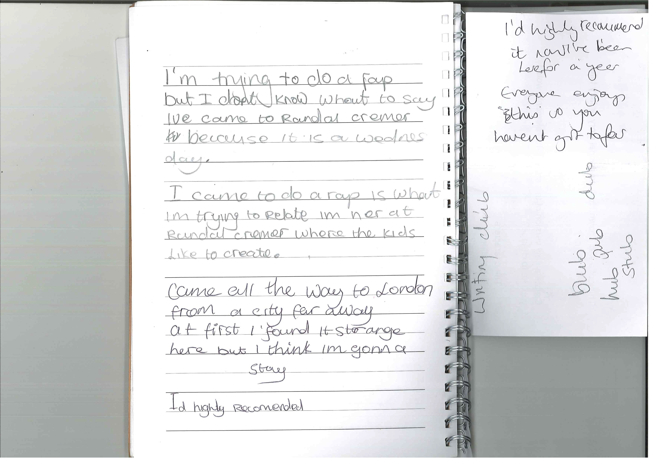

Darios spoke enthusiastically about MoS, feeling that they understood him as a writer:

Darios: I mostly don’t like writing, [WPL] knows that, but she gives me different stuff … It’s just that writing club’s more relaxed.

It was this type of specific support and understanding of his needs as a writer that motivated Darios to continue to attend MoS on a regular basis.

Only five of the YP articulated responses indicating the value of reading books in relation to ideas for writing. One YP described a really good writer as a person who reads lots of books, and was reading Roald Dahl books prolifically at the time of the interview. Two responses centred on technical elements that could be gleaned from reading books and an increased vocabulary in addition to giving ideas for writing:

Perry: It [reading books] gives more imagination, and it can like, you can know more like vocabulary and adjectives from books, and like if you are writing a piece of writing you can take ideas from there, like sentences, and sentence structures.

Christabella: Because there’s like more words, there’s more other words there, like it all stays inside your head.

Two further responses also focused on vocabulary, however both YP talked about what they would do if they came across a word they did not know. The first YP said he would use the internet to find the word’s meaning. The second YP went further saying he would not only look up the word but also then think about how to use it in his writing at school:

Robert: I don’t get ideas [from reading books] but I do get new words, like if I don’t know a word, like as I’m reading a book and I see a word that I’ve never heard before, so I’d usually look at the sentence and see if the word like rings a bell or if I don’t know anything about that word I just go onto the internet and type the word and see it’s meaning.

Jamal: Yes, because when I’m reading books it’s kind of like reading from a dictionary because you find new words that you haven’t understood before, so when I’m reading a Mallory Blackman book and I see a word that I’ve never seen before I’ll look it up in the dictionary then I’ll try and use it in my writing at school.

One YP described the value of what she could learn from an author, and why:

Eloise: Yeah, because an author has more experience in writing, so the language and vocabulary they will use will be nice and great, so then I could learn to use that kind of vocabulary and language in my writing.

Finally, one YP had a part in a travelling production of the West End show The Lion King so was not always at school. Whilst he was on tour he claimed he was reading for both academic and ‘work’ purposes:

Jamal: Yeah, um, when I’m with my show I just read at tutoring, because we have tutoring because we are not in school, and I just read, for example, if I’m on standby in my understudy show, I’ll read then…

The YP named his favourite authors as Mallory Blackman and Rick Riordan.

Case study project synthesis

The influence of reading on writing was most evident in the St Daniel’s project. The MoS workshop activities did not prompt any explicit reflections on what students had read (in fact, such exploration of students’ literacy experience is to be recommended); but the researchers noted the imaginative adaptation of various experiences in the writing. One boy’s story provides a good example: ‘the central event, where the two young male protagonists battle with giant spiders in a night-time forest, is reminiscent of a scene from a Harry Potter book/film. Narrated in the first person, Mario chose to provide the reader with lots of action, the excitement heightened by frequent sound effects (‘GRRRRRRRRR’) and an eye for sensual detail (for example: ‘I stopped. I turned around, and it blew its revolting breath at me’).

Another boy’s story drew on his online gaming experience, producing a narrative that read, in his teacher’s words, ‘like a dramatization of a scene from a video game’.

As the IOE study has pointed out in previous years, then, while YPs’ creative writing may draw on literary classic or class readers, it also draws productively on popular fiction, film, television, videogames and media franchises.

Summary
The majority of YP named favourite authors, and the last book that they had read or the book that they were currently reading during their final interviews. As the YP became more confident in their ability to write, a reliance on their reading for choice of content for their writing reduced over the three year period of the study. The YP developed greater confidence to use their own ideas more than ideas coming from works of professional authors. Only four out of 15 in the final year of the study saw the value of reading in relation to developing vocabulary and/or ideas for writing, preferring to write instead using their own ideas, knowledge, or experience. At the same time, positive recognition of the cultural value of a wide range of media sources was important in fostering motivated writing in classrooms.

Creativity in Writing

Figure 2 (derived from data in Table 4) is a succinct way to show broad trends of change in creativity in writing for all the case study YP over the three years of the research evaluation. The total scores for creativity (that are aggregates of the individual assessments of writing processes and products, based on the six creativity criteria, carried out by the two assessors) indicate that the creativity shown in the young people’s writing, and in the processes that led to the writing, were enhanced by the work of the MoS. It is important to note that the stratified random selection of all case study young people strengthened the validity of the findings through removal of some elements of selection bias. Random selection results in an average range of abilities and aptitudes in the young people commensurate with the MoS population characteristics overall.

One element of the broad trends of enhanced creativty was the mixed patterns of attendance by the YP across the three years. This was because each year some children left MoS. For example only six of the case study young people were part of MoS for all three years of the study, and also part of three years of data collection. The children from the case studies who left MoS were replaced each time by new children selected at random from the same school year as the child who left. Each replacement child necessarily had less time to benefit from MoS’s intervention (because they joined part way through the three year evaluation). So the broad trends of change were more likely to show a negative impact on overall creativity scores over the three years of study due to less exposure to the programme. This did not appear to be the case because the total scores showed a positive increase. However in order to better understand the impact of groups of children with different attendance patterns further analyses were also undertaken.

Figure 2: Creativity Progression: All case study young people

Table 4: Summary of creativity in writing scores

 | VW* | M | S | VS | VW | M | S | VS | VW | M | S | VS
 | Year 1 |  |  |  | Year 2 |  |  |  | Year 3
The sample of writing demonstrates imaginative adaptation of existing ideas | 3 | 6 | 6 | 2 | 0 | 5 | 6 | 4 | 0 | 5 | 3 | 7
The process of writing demonstrated imaginative adaptation of existing ideas | 3 | 7 | 6 | 1 | 0 | 5 | 6 | 4 | 0 | 4 | 3 | 8
The sample of writing demonstrates newness | 3 | 7 | 6 | 2 | 0 | 10 | 2 | 3 | 0 | 4 | 6 | 5
The process of writing demonstrated newness | 3 | 7 | 7 | 1 | 0 | 10 | 2 | 3 | 0 | 4 | 5 | 6
The sample of writing demonstrates value | 2 | 7 | 8 | 1 | 0 | 2 | 10 | 3 | 0 | 2 | 3 | 10
The process of writing demonstrated value | 2 | 7 | 7 | 1 | 0 | 2 | 10 | 3 | 0 | 1 | 3 | 11
Sub Totals: | 16 | 41 | 40 | 8 | 0 | 34 | 36 | 20 | 0 | 20 | 23 | 47
Total Score for Creativity:** |  |  |  | 250 |  |  |  | 256 |  |  |  | 297
*VW=Very weakly; M=Moderately; S=Strongly; VS=Very Strongly
** (VWx1)+(Mx2)+(S*3)+(VS*4)

The strongest positive change in the development of creativity in writing was seen for the YP with three years of attendance (Figure 3, and see further tables showing creativity criteria, and qualitative analysis, below). This was predicted because the YP benefitted maximally from most input from the intervention that aimed to enhance creativity. This finding is interesting because there is very little published research that has shown the ways in which a particular intervention can enhance creativity in writing.

Figure 3: Creativity trajectories 3 year attendance

[Blank space]
Considerable positive change was also evident in the YP who had two years of attendance, either from research year one to year two, or research year two to year three (see Figure 4: no year one assessment was available for John).

Figure 4: Creativity trajectories 2 year attendance

These positive trends, consistent with greater attendance, also applied to children who joined MoS but for whom there was only one year of research data, because they left MoS.

Table 5: Creativity of YP with one year of research data

 | Mean Overall Creativity Score | Standard Deviation
Selected in Y1 of study. 1 Year in Study. 1 year at MoS. | 13.00 | 7.07
Selected in Y2 of study. 1 Year in Study. 2 years in MoS. | 15.00 | 4.24
Selected in Y3 of study. 1 Year in Study. 3 years in MoS. | 18.50 | 4.51

Looking at the individual assessment criteria for creativity, no YP in Y3 were assessed for creativity as ‘very weak’ in any area of writing process or writing product (see Table 3). Correspondingly there were more YP who exhibited very strong levels of creativity in their writing. These trends were consistent with patterns that had first been seen in year two of the research. There was an even more noticeable trend to greater ‘value’ in relation to creativity perceived by the assessors. This could have been partly due to a subjective response on the part of the two assessors who had a more holistic knowledge beyond the writing samples of each YP involved.

Originality remained difficult to assess. When comparing pieces from the same session, for example, it was noticeable that for some YP the genre provided a solid structure or framework for writing. So two responses to an activity where the YP were writing advice for visitors who had never been to London before showed that whilst both YP had a clear sense of audience, and information that they might need to write down in order to help someone new navigate the city, their approaches and outcomes were very different in terms of how they chose to convey that information. Perry wrote a planned letter of advice for visitors to London, for example. The final piece was essentially a rewrite of most of a highly detailed plan in letter form (Figure 5). Marlon on the other hand took a very different approach. His LONDON! piece (Figure 6) did not involve any planning and stood out through its eye-grabbing title and illustrations accompanying the text. Both pieces were given ‘very strong’ in relation to value for process and product.

[Blank space]

Figure 5: Perry

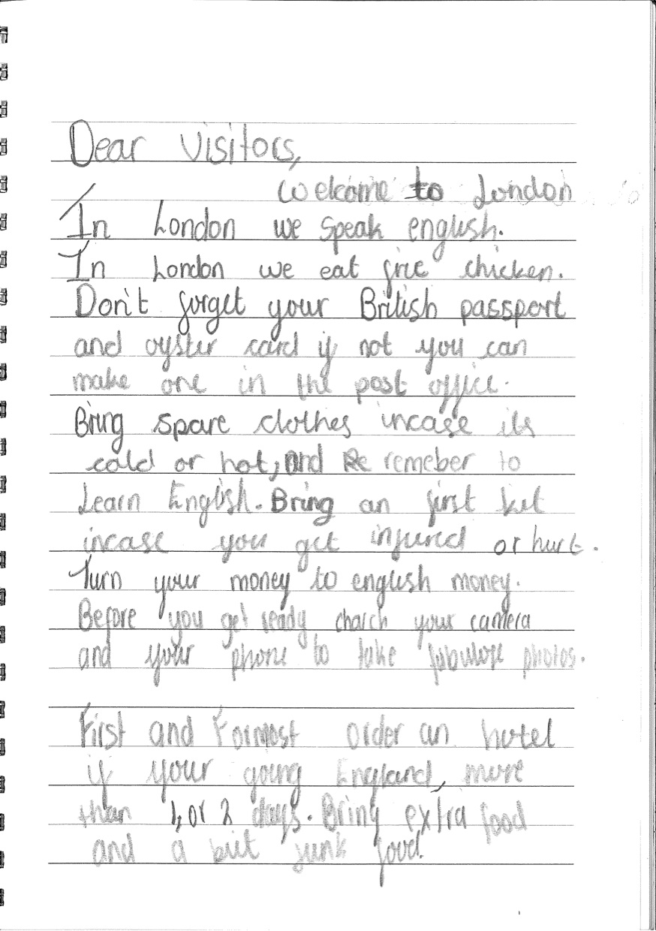

Figure 6: Marlon

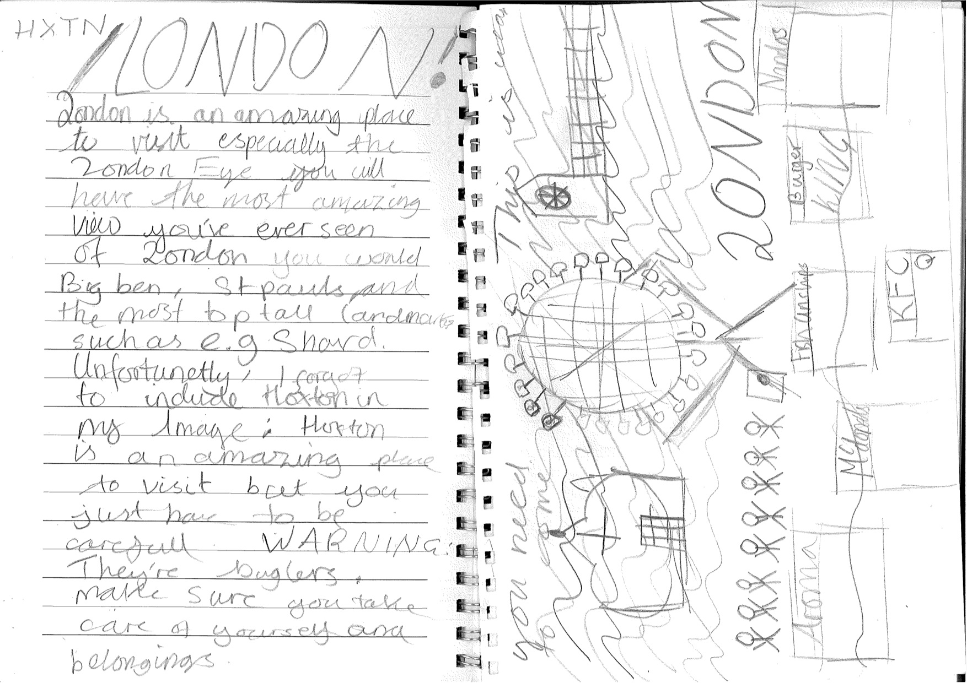

Creativity development: YP who attended for three years

This section begins by presenting the case study of one YP who was present for three years (although he left MoS before the end of Year 1 but returned in Year 2.) and who showed exceptional development in terms of creativity, progressing from assessments showing moderate creativity to assessments showing very strong creativity. His development, as recorded through the creativity assessment tool, is shown in Table 6:

Table 6: Marlon’s creativity development

Creativity Assessment Tool | Judgements
 | VW* | M | S | VS
The sample of writing demonstrates imaginative adaptation of existing ideas |  | y1 | y2 | y3
The process of writing demonstrated imaginative adaptation of existing ideas |  | y1 | y2 | y3
The sample of writing demonstrates originality |  | y1 y2 | y3
The process of writing demonstrated originality |  | y1 y2 | y3
The sample of writing demonstrates value |  | y1 | y2 | y3
The process of writing demonstrated value |  | y1 | y2 | y3
*VW=Very weakly; M=Moderately; S=Strongly; VS=Very Strongly

Marlon became a fluent writer over the three years he had been involved with the study. His baseline interview in Year 1 began with a clear (and typical) focus on the transcriptional elements of writing, accounting for the somewhat short pieces in his writing book at the time. Marlon returned to the Saturday morning workshops during the second year of the study. He explained that he left because his friends left, making it clear that this was an important prerequisite for attendance. By Year 3 Marlon was sure of his capabilities, which he attributed to his involvement with MoS:

A:…before [coming to MoS] I wasn’t all that good, but now I’m really good.

By Year 3 Marlon no longer mentioned the technicalities of writing. He had shown confidence to experiment with writing activities during MoS sessions. Looking at his writing samples, Piece A was a guide for someone who had never visited London before, one of the conference preparation activities undertaken by the Saturday YP during the summer term. Marlon showed an awareness of the genre and took a creative, sophisticated approach; the piece included a contents page for the guide for example, and he chose a specific layout. It was produced during a single session at MoS. Both this piece and piece B, LONDON! (Figure 6), were written as a result of how engaged Marlon was with his writing, perhaps partly because he was an expert on London as it was his home and he was therefore writing about what he knew. It could be argued however that his writing also flows because he is now a competent, fluent writer. LONDON! provided clear advice on staying safe in the capital and was accompanied by a detailed illustration. This augmented the piece in terms of conveying the atmosphere of the city and the writing content, but also showed a strong awareness of genre and a desire to connect with his audience.

Marlon said that motivation helped him to write. Unpicking motivation for him involved two key elements. The first of these was the degree of freedom he felt in interpreting a writing activity. He could make choices in relation to the writing that he produced; a characteristic that began to emerge in Year 2 as his confidence within the MoS writing environment increased. His Year 2 writing showed, for example, how he was already beginning to adapt frameworks to suit something he was interested in. A second key element in relation to motivation centred on Marlon’s perspective of the writing environment at MoS compared with that of school, which also involved freedom about when, what, and where to write. In Year 2 he stated:

Marlon: …in my school it’s like they force you to write, but in here you can just go to the sofa, write, go to a different place to write, like you are free here, but in my school it’s like you are restricted to do different things.

He reiterated this perspective in Year 3:

Marlon: Yeah, we are quite like free here, but at school you have to do this and you have to do that…They [school] don’t like, they...they like, they force you to write something, you have no choice but to do it.

The consistency of language in both these comments recorded a year apart, and his participation in an environment where he felt “free” had much to do with Marlon’s willingness to engage with the writing process during MoS sessions, unlocking his creativity.

Five out of six of the YP, Marlon, Mario, Daniel, and Christabella, showed a steady increase over the three year period of the study in relation to judgements from the creative assessment tool (see Table 7). One YP did not follow the same pattern and in fact her Year 3 judgements were lower in some cases compared with with Years 1 and 2. The six YP between them displayed a range of ability as quantified by the tool, captured as Very Strongly across the three year period for one YP in all categories, to Weakly in Year 1 for another YP in all categories, but achieving Moderately in Year 3, apart from Value where the YP was assessed as Strongly.

Table 7: Creativity trajectories of YP who attended for three years

Eleanor | Judgements* |  |  |  | Elizabeth | Judgements
 | VW | M | S | VS |  | VW | M | S | VS
The sample of writing demonstrates imaginative adaptation of existing ideas | y1 | y2 y3 |  |  | The sample of writing demonstrates imaginative adaptation of existing ideas | y1 | y3 | y2
The process of writing demonstrated imaginative adaptation of existing ideas | y1 | y2 y3 |  |  | The process of writing demonstrated imaginative adaptation of existing ideas | y1 | y3 | y2
The sample of writing demonstrates originality | y1 | y2 y3 |  |  | The sample of writing demonstrates originality |  | y1 y2 y3
The process of writing demonstrated originality | y1 | y2 y3 |  |  | The process of writing demonstrated originality |  | y1 y2 y3
The sample of writing demonstrates value | y1 | y2 | y3 |  | The sample of writing demonstrates value |  | y1 y3 | y2
The process of writing demonstrated value | y1 | y2 | y3 |  | The process of writing demonstrated value |  | y1 y3 | y2
*VW=Very weakly; M=Moderately; S=Strongly; VS=Very Strongly
Mario | Judgements |  |  |  | Marlon | Judgements*
 | VW | M | S | VS |  | VW | M | S | VS
The sample of writing demonstrates imaginative adaptation of existing ideas |  | y1 y2 | y3 |  | The sample of writing demonstrates imaginative adaptation of existing ideas |  | y1 | y2 | y3
The process of writing demonstrated imaginative adaptation of existing ideas |  | y1 y2 | y3 |  | The process of writing demonstrated imaginative adaptation of existing ideas |  | y1 | y2 | y3
The sample of writing demonstrates originality |  | y1 y2 | y3 |  | The sample of writing demonstrates originality |  | y1 y2 | y3
The process of writing demonstrated originality |  | y1 y2 | y3 |  | The process of writing demonstrated originality |  | y1 y2 | y3
The sample of writing demonstrates value |  | y1 | y2 | y3 | The sample of writing demonstrates value |  | y1 | y2 | y3
The process of writing demonstrated value |  | y1 | y2 | y3 | The process of writing demonstrated value |  | y1 | y2 | y3
Daniel | Judgements |  |  |  | Eloise | Judgements
 | VW | M | S | VS |  | VW | M | S | VS
The sample of writing demonstrates imaginative adaptation of existing ideas |  |  | y1 | y2 y3 | The sample of writing demonstrates imaginative adaptation of existing ideas |  |  |  | y1 y2 y3
The process of writing demonstrated imaginative adaptation of existing ideas |  |  | y1 | y2 y3 | The process of writing demonstrated imaginative adaptation of existing ideas |  |  |  | y1 y2 y3
The sample of writing demonstrates originality |  |  | y1 y2 | y3 | The sample of writing demonstrates originality |  |  |  | y1 y2 y3
The process of writing demonstrated originality |  |  | y1 y2 | y3 | The process of writing demonstrated originality |  |  |  | y1 y2 y3
The sample of writing demonstrates value |  |  | y1 y2 | y3 | The sample of writing demonstrates value |  |  |  | y1 y2 y3
The process of writing demonstrated value |  |  | y1 y2 | y3 | The process of writing demonstrated value |  |  |  | y1 y2 y3

Looking briefly at each of the six YP as individuals, and taking those four YP who showed an overall increase in their creativity consensual judgements first, Marlon moved from Moderately in Year 1 for every category to Very Strongly, apart from originality where he scored Strongly (see Table 7). Mario moved through a clear trajectory of creative development from Moderately in Year 1, to Strongly in Year 3 with Very Strongly for value. Daniel moved from Strongly in Years 1 and 2 into a consistent Very Strongly in all categories for Year 3. Finally Eleanor, who scored Very weakly in Year 1 was given Moderately in all categories apart from Value where she scored Strongly in Year 3. According to the creativity assessment tool, on one level Eleanor has been consistently the weakest writer overall in the study, however she has remained at MoS and clearly perceived herself to be a capable writer. She said, “at Ministry of Stories you can write anything”. This year she revealed ambitions to be a politician. Eloise on the other hand was the most consistently strong writer over the three year period, having scored Very Strong for every category every year. However, in spite of high levels of creativity, this year saw her disengaged from the writing process, revealed in the much lower scores for her perception of enjoyment for writing at MoS and school: 6/10 and 5/10 respectively (this was discussed in the Motivation to Write section of the report). Finally, Elizabeth saw some of her Year 3 judgements move down as opposed to up. Her imaginative adaptation judgements went from Very Weakly to Strongly in Year 2, then back down to Moderately in Year 3. Value also moved from Strongly in Year 2, having moved up from Moderately in Year 2. Originality has remained at Moderately throughout the three years she has been a participant. Whereas Elizabeth used to be the one to take the lead and scribe for her peers (in Year 1 for example), Year 3 saw her happy for others to scribe for her, either her friends when working with a group or working with a mentor one-to-one (two out of the three pieces that made up her writing sample were scribed by a mentor). Again, Elizabeth’s judgements must be interpreted as part of a wider narrative that has seen significant changes in her personal life impacting on her perspective of school (she gave enjoyment of writing at school 0/10), and a disengagement with the writing process.

YP’s Creative Approaches to Writing

Two main creative approaches were observed. The first of these was in the way a YP took a writing task or activity and extended it independently through their own personal response, for example Mario with his ‘I love/I hate’ list, a warm-up activity for one of the observed Thursday MoS sessions. Mario engaged with a mentor for this activity, telling her as she sat down to join him, “I’m trying to think of all the things I hate at home.” The mentor encouraged him to articulate these and he listed them in his book. The mentor then asked, “What about the things you love at home?” and Mario wrote his I love list. Mario was so pleased with his lists that he began to develop his ideas into a poem (My Poem - Figure 7), seen on the left-hand side of his page. This was completely spontaneous on his part and a personal response to perceived achievement within the context of a specified writing task. The lists became an integral part of the creative writing process for the production of his poem.

Figure 7: Mario

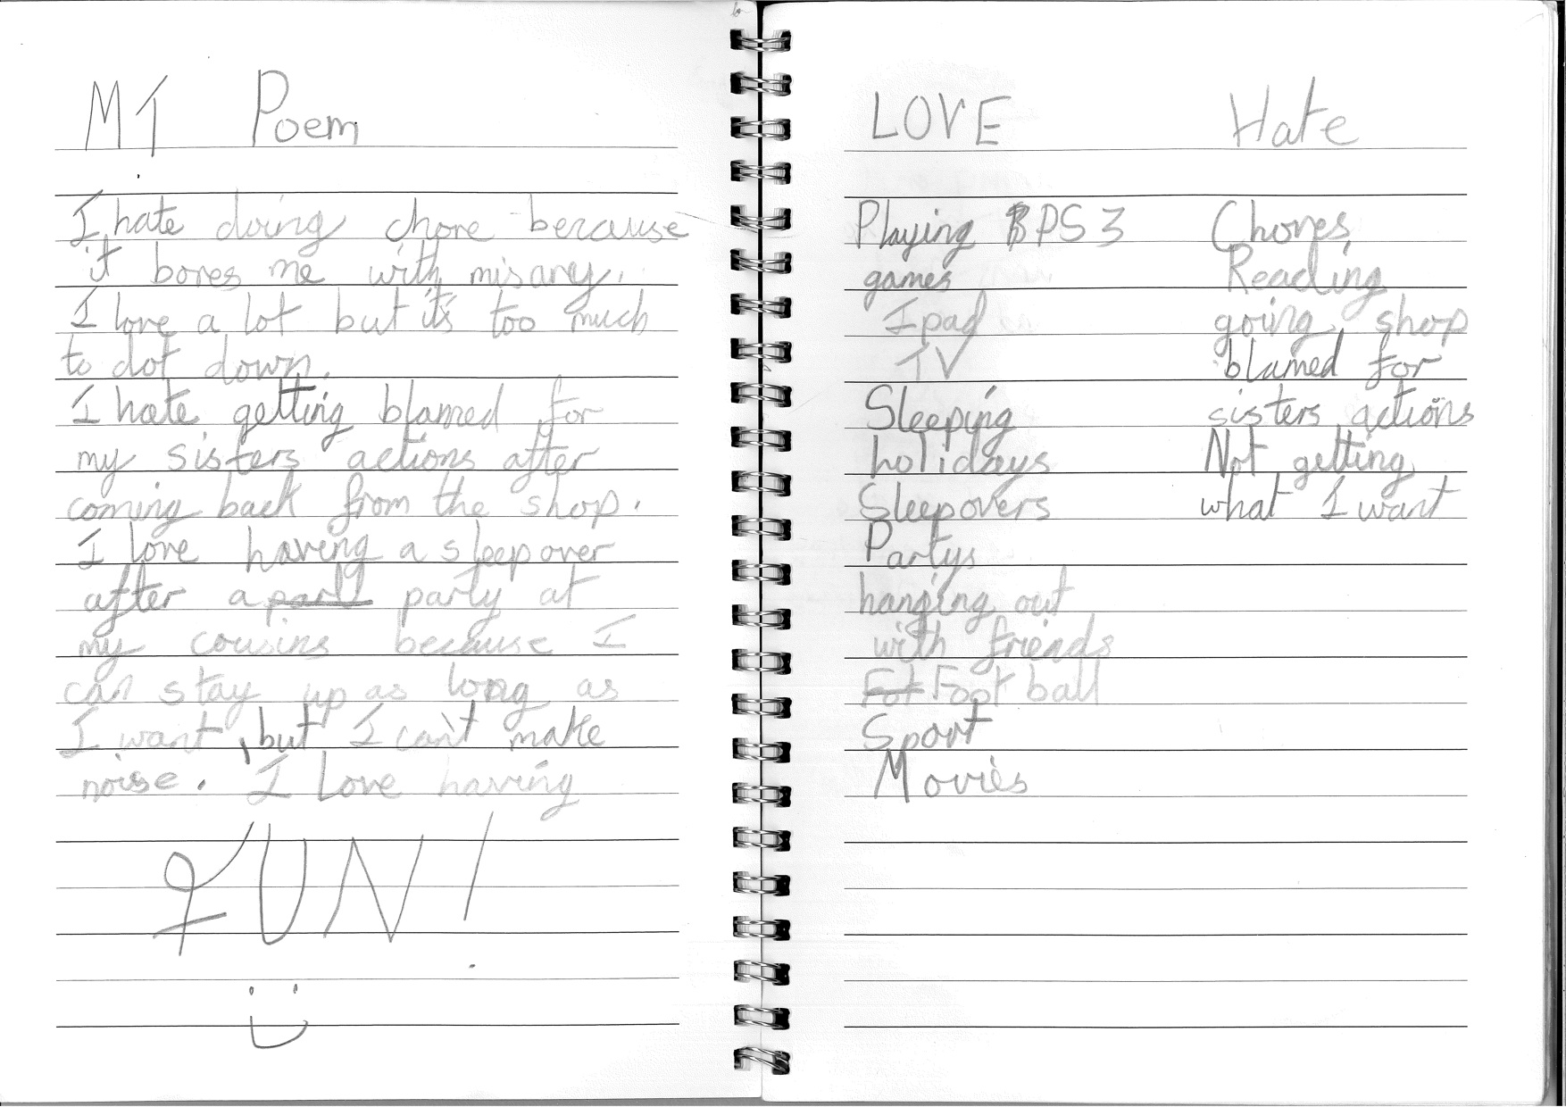

Figure 8: Daniel Planning for Piece A

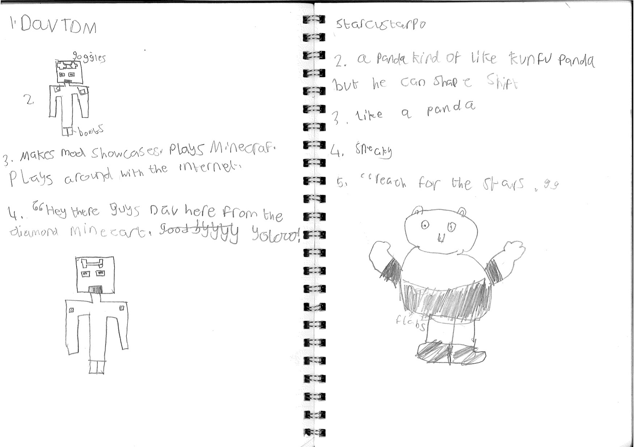

Figure 9: Daniel Piece A

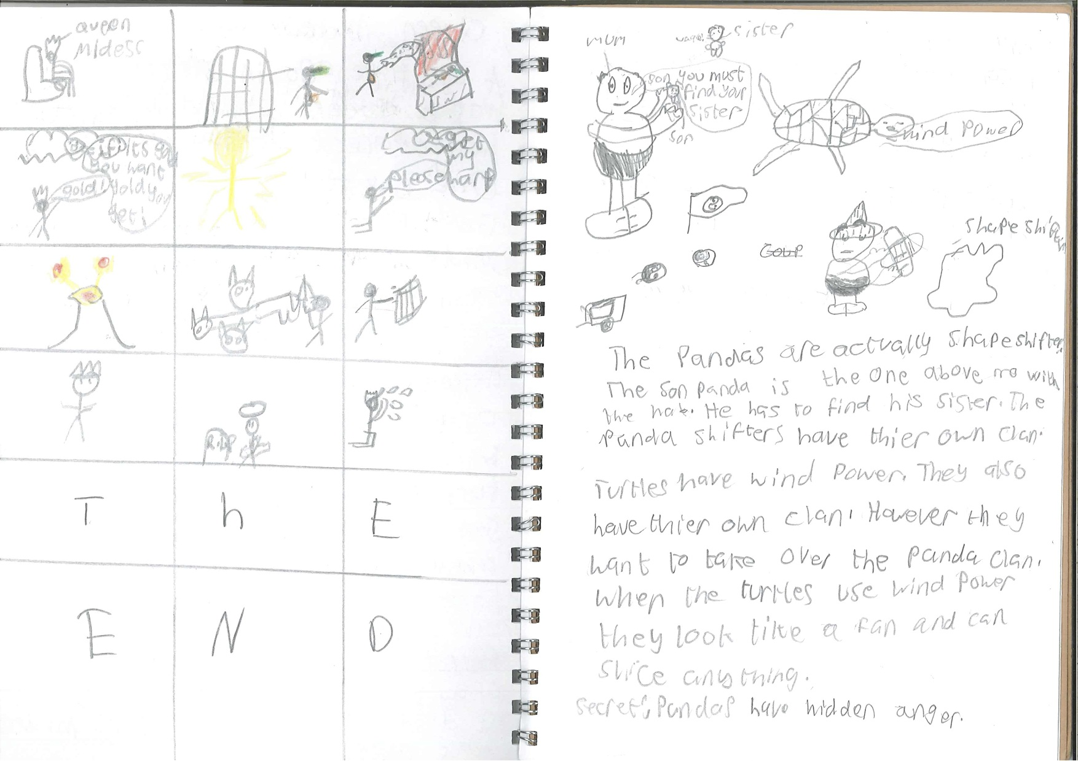
A second creative approach was observed in relation to writing process where the planning element of the piece was integral to the final outcome. Daniel, for example, planned and illustrated all his stories. He used illustrations and annotations as part of the planning process to help him develop characters and to give him visual images from which to further develop his final ideas. Figure 8 and 9 showed Daniel’s writing.

Underpinning both creative approaches described above was the understanding on the part of the YP that whatever they wrote would be valued. In the words of a rap written by Daniel: “MoS means you write some stories Amazing You get praised with glory” [sic].

YP’s Perceptions of Creativity

Four patterns of perception emerged from the interviews with the YP. For one of the YP, creativity was inherent within the MoS approach, providing inspiration for personal ideas for writing:

R:…what do you think helps you to write at Ministry of Stories?
Jonathan: The creativity, because when they give you some ideas you can kind of build up on that and you make your own idea.

For two of the YP, participation at MoS engendered creativity within themselves. The comments alluded to the particular writing environment that the MoS created for the YP:

Jonathan: I think it’s [MoS] a good place because it’s like you come with your friends, you can invite them, and kind of write about your own things, come up with lots of creativity, and have fun.

Marlon: …I feel like before I came I wasn’t that like creative, like to create fictional stories, but now I feel different, I really like to create them because you can just make up anything about the character, you can write anything about it, it doesn’t have to be real, as long as you make it feel to the reader as it is real.

A third perception related to that of the YP as creative individuals. Two responses revealed how the YP assess their level of creativity; the first YP did not feel they were ‘the best’ in terms of creativity, however the second YP replied with conviction and an acknowledgement that his creativity had increased since he began attending MoS sessions:

R: What do you think helps you to write?
Robert: Well first of all you need to have an idea, second you have to be creative, and third of all you have to be imaginative, to be able to write.
R: OK, and are you imaginative and creative, do you think?
Robert: Yeah, I wouldn’t say the best, but I would say imaginative.

Darios: How do I get my ideas? I’m just creative.
R: You are just creative. That’s a wonderful thing to be able to say. Have you always been creative?
Darios: Not as much before I write here.

A final perception for one YP centred on their personal understanding of creative writing:

R: What type of writing do you like to do best?
Daniel: I like to do creative writing best, because I usually have most ideas for creative writing so it’s much easier…Creative writing is when you write anything of your own ideas or varieties and you make it into a story.

A comment from the WPL in her interview this year corroborated the perceptions of the YP in terms of the writing environment that she was trying to create:

WPL: I think that I’m, as a practitioner, very process orientated I guess, and I think that’s something that is important to me in the workshops that I’m leading, that there is that focus on the process that people are going through and I guess that kind of ties in with wanting to find ways for people to have creative freedom …

The comments from the WPL tie in with the overall aim of MoS to improve creativity in writing; perhaps the findings on perceptions might provide strands to further investigate and define with the YP in general to develop a co-constructed understanding of creativity at Mos. This might move the YP on from their unanimous, unified response for attending MoS sessions, which is to improve their writing. If they could understand that improving their writing could move beyond transcriptional and compositional elements which the YP recognise and sometimes quantify in their interview responses, they may be able to see how creativity might also be an integral element of the writing process and how it manifests itself in their own writing.

Case study project synthesis

There is no doubt that the three projects in the Year 3 case studies promoted a wide range of creative processes and outputs. These included experimental writing in secondary school classrooms, a wide range of experimentation with short-form poetry genres in the Poetry-To-Go project, and a productive synthesis of word and image in the Picture Books project in which children wrote in collaboration with professional illustrators.

The only project to use the consensual judgment tool this year (because it was possible to deploy it in discussions between the teachers and the researchers) was the St Daniel’s project. In this case, the scores were grouped across Some and Strong, with two scores for Very Strong under the two ‘value’ categories. This can be seen as a very positive outcome, given the initial low motivation and attainment of the two Year 9 bottom sets participating in the project.

Across these projects, some contributory factors in the creative process can be reasonably reliably identified. They include:

- The imaginative adaptation of prior experience of fictional narratives in different media
- The freedom to choose focus and content, not always offered in school
- The stimulation of lively, physical workshop sessions, often in the form of games and often involving physical artefacts
- The modelling and collaboration of professional writers and illustrators
- The collaborative model of writing, with sustained talk, feedback, listening and encouragement from mentors and peers
- The opportunity to write for real audiences.

Nevertheless, the creative moment at times remains difficult to explain. The best example from this year’s case studies is the production of a line, in the Poetry-to-Go project, describing a pomegranate:

Pomegranate, a little spiky lid on a plump round body
(In Turkish we call it ‘nar’)
Waiting for adoption.

The generation of the first two lines was clear enough, emerging from the two girls in question taking turns to think of descriptive words, and remembering the Turkish word. But the third line is more difficult to explain, except to speculate, as the report says, that ‘that the process of pondering at leisure over a tangible object, embedded in a cultural setting, in collaboration with others, characterised the conditions out of which the creative impulse was born.’

Summary

There was clear evidence of the MoS approach resulting in higher levels of creativity in the young people and their writing. The data supporting this finding includes positive trends in the creativity assessments over three years, the young people’s opinions of their creativity development, and the evidence from the nine case studies of MoS projects. Creativity, as ever, continued to be manifested in many different aspects of the writing process, including narrative composition across different media, different genres, and for a range of purposes.

In Year 2 the assessments of imaginative adaptation of cultural resources were higher than in Year 1, as were the assessments of originality measure. Year 3 particularly saw evidence of the YP revealing a greater understanding of themselves as writers and showing more originality in their responses to writing activities, for example as they wrote with more fluency including in vital technical aspects such as their handwriting. They developed their own writing voices through engagement with a creative writing process which had become intrinsic to them as confident and competent writers. However, the creative writing process was not the same for every YP, revealed in a range of responses to writing tasks and activities, and in different perceptions of creativity. Each YP was assessed as showing a different profile of creativity development suggesting that creativity is not an evenly distributed trait. Findings in relation to the six YP who were involved over the entire three year period of the study showed that it is important to understand creativity as unique to an individual YP rather than expecting the same process and outcomes for all. Part of the unique response to creativity includes recognition of the context of experiences outside of MoS that are part of YP’s lives.

Expression and Communication

Communication and expression emerged in three main areas: communication and expression in the YPs’ writing, particularly writing with a specific audience in mind; communication and expression in relation to writing in an environment that differed from that at school; and communication and expression in relation to working with mentors.

Communication and Expression within Writing

Preparations for the Write for a Bright Future conference had an impact on communication and expression for the YP, particularly the Thursday and Saturday groups. They wrote with a clear audience in mind and showcased London, their home, within their writing. Writing about what they knew proved empowering, and the writing activities they engaged in originally stemmed from collaborative discussions, thus involving them in the planning of session content from the outset, as explained by the WPL:

WPL: …we did a consultancy with the groups back in early 2015 where we asked them [the YP] what involvement they wanted to have in the conference, so it’s all come from different group members …

One of the writing activities involved the YP writing letters back to MoS groups around the world who had sent story endings to the Saturday group’s cliff-hanger. The YP had to identify what they liked about the story endings, and why. The WPL’s comments in the following extract focused on this particular activity but also corroborated Mario’s newfound approach to writing this year:

WPL: I think he’s far more willing to try stuff that’s out of his comfort zone … now he kind of looks maybe a bit more openly at things, and like has more things that influence his writing … when there was that real audience, he really got into the idea of writing to the other centres, and he wrote some really lovely letters when we were doing the responses … one of the stories he was replying to … had been written by someone from Sweden [see right hand page of Figure 10] … and it was only four or five lines, and he read it and he wrote this really lovely considerate letter about how many ideas they’d got into a little paragraph … and he kind of picked up on the fact that they were a younger writer, and I think that just showed a real maturity.

Figure 10: Mario Piece C

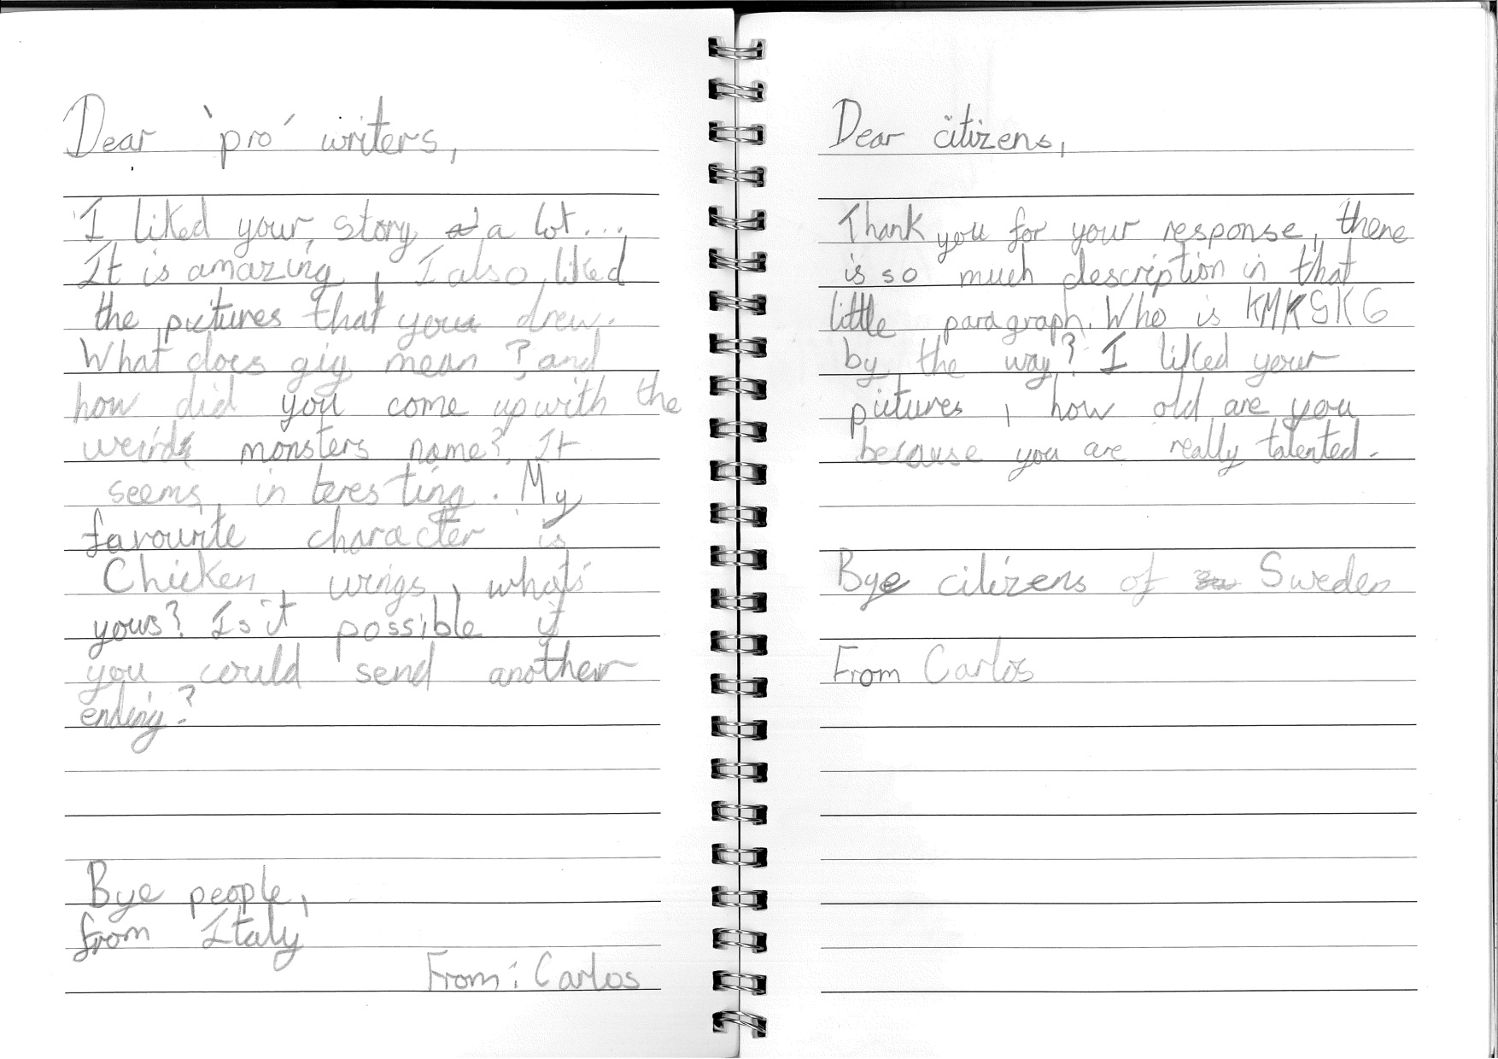

A greater maturity in their writing, including a strong awareness of audience and greater control of the transcription elements of writing, enabled many of the YP to express their thoughts and ideas fluently on paper. As one mentor stated:

M1: …it seems like they’ve found writing now as something that’s theirs, that can keep them afloat in other situations.

12 out of 15 of the YP this year were engaged confidently in the writing process. The three weakest writers in the cohort this year belonged to the Wednesday group (based at the school) and often relied on mentor support to scribe for them. The Wednesday group were problematic this year, however the WPL continued to find innovative ways to engage them. Their involvement in the conference centred on the development of a radio podcast describing life in Hackney for YP on the brink of moving to secondary school and going through the experience of SATs. Whilst this involved writing scripts to be recorded, again with a clear focus on how to communicate with a particular audience, most of the writing was collaborative, for example undertaken in small groups or in pairs with one YP acting as scribe. The Wednesday group also visited a real radio station during the summer term to record a chosen piece of writing from their MoS books. The rationale for these activities was to try to take some of the pressure off the YP who were ultimately still writing in a classroom during MoS sessions at the end of the school day. Some of the comments made by the Wednesday group YP reflected the WPL’s innovative approach. When asked what it was about MoS that kept her coming back, Celine said, “the fact that we get to write whatever we want.” Whilst being able to take a writing activity and personalise it was commented on across all three writing groups, the Wednesday group were unique in this respect in that all seven YP made exactly the same point.

It is important to acknowledge that the YP still showed innovation in relation to communication and expression beyond the writing activities they engaged in in preparation for the conference. Daniel’s Winter Wonderland story (Figure 11) used one page, the final page in his MoS writing book. He adjusted his writing so that the story fitted the page and the accompanying illustrations on the inside back cover gave more information about the particular characters.

Figure 11: Daniel

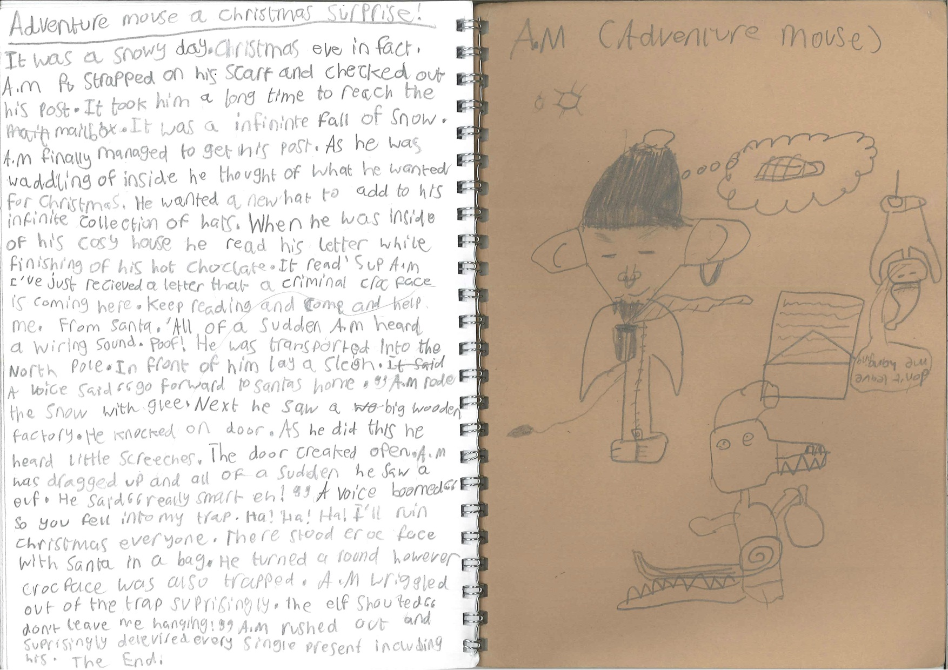
The YP’s use of the word ‘imagination” in their interviews provided further evidence of a stimulus for communication and expression within the YPs’ writing:

R: What do you think helps you to write?
Elizabeth: …I don’t know, my imagination.

R: And what is it about Ministry of Stories that makes you want to keep coming?

Perry: Because I use my imagination.

Robert: …you have to be imaginative to be able to write.

Jamal: I think it’s a good club for children to…put their imagination on a piece of paper.

One of the YP commented specifically on the contrast between communication and expression when writing at MoS and when writing at school:

Jamal: I think what helps me to write is the fact that I’m using my imagination and not somebody else’s … in Ministry of Stories it’s kind of like encouraging you to put down your own ideas … It’s different in school because in school you are not really using your imagination as much, because you have to write about a certain thing, and a certain thing that happened to your characters.

Jemima simply said, “The writing I do here [at MoS] is more imaginative.”

Communication and Expression and the Writing Environment

There was a clear understanding of the less formal approach to writing that the YP encountered at MoS compared with that of school and how this impacted on the writing process. The MoS continued with a policy encompassing a focus on writing content more than correct spelling or grammar. This was revealed in the YPs’ books and in the pieces chosen for the creativity assessment tool this year, yet in terms of feeling able to communicate and express themselves in their writing the satisfaction the YP felt with the MoS approach was clear, as Edith’s comment suggested.

Edith: It feels different from at school, you know like we still do a type of literacy but it’s different from school literacy. School’s all that pressure of writing everything correctly … you have to write a story about a certain thing, you can’t just ... but in writing club with things like you can make your imagination run wild, you can do anything you like from a song to a poem to a story.
R: … what’s it like for you to let your imagination run wild?
Edith: I think it’s quite fun, because you don’t have teachers behind you that are pressuring you to do all the spelling correctly or your handwriting has to be in a certain way, I feel more free.

Edith was also one of two YP who mentioned the value of talking when writing:

Edith: … I think it’s a bit different because the teachers, you can talk to your friends, you can ask ideas of each other, but in school you are not allowed to talk, you have to stay quiet and do your work.
R: Does it help you to talk when you write?
Edith: Yeah, I think you do, because you hear somebody else’s idea and that will make you not necessarily copy but give you a clear idea what you want to do.

Communication and expression also manifested itself in challenging topics that the YP were not afraid to explore within their writing at MoS:

R: … can you tell us what your story was about?
Jemima: It was about a clown who almost died and then he became into a mental state, then at the end he moved to Canada and then he died … I guess I just wanted to add suspense to it.

R: Just give me a rough idea about what it’s [Edith’s story] about, apart from it being about teenagers? What else is happening in it?
Edith: It’s about people getting missing, getting lost, and getting killed.

Knowing the YP as individuals proved important this year for the WPL. One YP who went through some difficult personal experiences used some of these within her writing this year. The WPL knew when she was writing authentically about her experiences and when her writing reflected reality becoming blurred with fantasy, sometimes resulting in some very graphic content. Knowing the YPs’ personal circumstances was important in relation to mentors, particularly new mentors, who were sometimes alarmed at the content of the YPs’ writing. One mentor debriefing session involved a discussion on how to respond appropriately to a ‘dark’ story. The WPL suggested the mentors perhaps say, “What inspired your story?” and then to alert her during a session if they were concerned at all.

Whilst the MoS offered a conducive environment for writing for the YP that differed from the perceived stricter school context, it was not without its parameters. Observations showed the WPL taking ultimate responsibility for a range of aspects of behaviour and expectations amongst the YP. During a mentoring briefing session one issue of a group of YP who had been speaking unacceptably about another peer at school in a previous session was discussed. Whilst the WPL had tackled the issue at the time the mentors were told that if they saw it happening again they needed to alert her immediately and not try to deal with it themselves.

A final consideration in relation to the writing environment was the importance of the sharing part of the sessions which this year were allocated a greater prominence allowing the YP to have the optimum potential to share their writing with their peers. The WPL ran a policy of inclusion and again used innovative ways to draw the YP out and encourage them to share, as the following field note extract reveals:

4.40pm WPL organises stage and audience. She runs through how to be an audience with the YP - watching, listening, no fidgeting. YP then share their stories. Some read from where they are, some come to the front to share, some ‘perform’, some directed a mentor to read/perform for them. The YP are encouraged, sometimes supported to share, for example WPL sitting alongside. WPL encouraged one YP who had nominated a mentor to perform to come up as well “in case he got stuck”. Another YP - “come up here in case I get stuck”. Another pattern was the WPL reading one sentence, the YP the next, and so on (Extract from observation, 4.6.15).

Communication and Expression with Mentors

There were many positive comments about the value of the mentors, such as the positive suggestions and positive challenges they offered to the YP. However, three YP from the Wednesday group felt that sometimes they were inhibited by the mentors’ presence. This group began when the YP were in school year four, and there had been no further recruitment to the Wednesday group over the three year period of the study, hence many of the original YP from this group had left. There were eleven YP in the group this year with up to 7 mentors each session. Whilst some of the personal circumstances of the YP were difficult this was an abnormally high mentor to YP ratio which contributed to changed dynamics across the group. The MoS was thinking through how to be involved in the school for the following year now that the group had naturally come to an end, but a repeat of a situation such as this one would need to be carefully avoided. Mentors expressed some frustration at the circumstances of the group, however remained committed to their role:

M2: … it’s quite challenging working here because the kids are tired some times and distracted, and sometimes they don’t want to get involved, don’t want to engage, but I don’t feel that’s any reason for me to just not come, so just kind of keep at it really, sometimes I sit there feeling a bit isolated …

Another issue concerning mentors, particularly amongst first time mentors, was how and where they placed themselves within the writing space in relation to the YP. From the observations of sessions, new mentors unfailingly mentioned struggling to find a way to engage with the YP during the debriefing session. New mentors also talked about not knowing when to talk to YP and the difficulty they had in knowing how to read individuals in terms of the support they might or might not need. On the other hand, an example of positive interaction was observed when an experienced mentor said, “How was your day at school girls?” as she sat down to join them at their table. It is models like this that could be developed to support new mentors. Whilst the WPL scaffolds the mentor briefing well, there is room for improvement in terms of information for new, often very nervous, mentors to be included to offer them greater support.

Case study project synthesis

Communication and expression were generally commented on positively in the three case studies in Year 3. A specific example was the dialogue between the children and the illustrators in the Picture Books project. One boy, for instance, maintained a productive discussion with his illustrator, not only communicating his story (about a piece of French Toast on holiday in Spain), but partly illustrating it himself so that the professional illustrator was able to build on his ideas. This example demonstrates well the multimodal nature of communication, which project planners are encouraged to incorporate into their thinking.

Another example was the confident communication of children in the Poetry-to-Go project with members of the Hoxton business community. On the one hand, they had an unfamiliar topic to broach – writing poetry about the businesses; on the other hand, in one case at least, they conducted the discussion partly in Turkish, demonstrating the importance of bilingualism in particular contexts, and the cultural resources available to this community.

Summary

Communication and expression emerged in four main areas. The first of these was within the YPs’ approach to writing related to the way in which they were able to express themselves and communicate through their writing, both as an individual enterprise and as a social, collaborative activity. The second was within the YPs’ perceptions of the MoS environment, for example how it supported a freer approach to writing. The third area involved relationships between mentors and the YP where positive outcomes outweighed negative ones. It is likely that the YP’s age-related development and experience was an influence in relation to expression and communication over the three year period of the study. Fluency in transcription skills such as handwriting enabled the YP to compose with more confidence. Finally, the fourth area of communicative competence could be seen in oral communication, where confident expression was supported by the MoS, both within the workshop environment and outside in the community.

Attainment

Analysis was conducted on writing and reading attainment data (Key Stages 2 SATs) for 131 children who completed year 6 in July 2015. The children studied at three primary schools in the London Borough of Hackney. Twenty-five had participated in the Ministry of Stories programmes; the remaining 106 had not, but were included in the analysis as a comparison group. We excluded from the comparison group an additional six children identified as having acute SEN.

The group of children who participated in the Ministry of Stories were categorised by the number of years of involvement in the programme: 12 children who have been involved for 3 years, 6 for 2 years and 7 for a year or less. The analysis was conducted for two main groupings: 1) Children who had participated in any Ministry of Stories vs. those who had had none; 2) those who had 3 years of participation vs. those who had no participation.

Children who take part in out of school programmes relating to academic subjects are potentially different from their peers – in terms of issues such as enjoyment of school, interest in literacy, personal motivation, family support for learning. Those that remain involved over multiple years are also likely to be different from those who undertake this for just one year. We did not have access to information relating to these issues for all the children in this cohort. However, we obtained Key Stage 1 (end of year 2) statutory teacher assessment scores for reading and writing for them, which provides a baseline of attainment prior to any possible involvement with the Ministry of Stories. These Key Stage 1 scores show that a significantly lower proportion of Ministry of Stories participants than their peers achieved below average attainment reading scores at year 2; however their year 2 writing scores were not significantly different. These year 2 scores have be taken into account in the analysis of year 6 reading and writing scores presented below, to ensure a fairer comparison.

The numbers of children involved in this impact analysis is small, making it difficult to achieve differences that we can be certain are real (‘significant’), rather than chance findings. Many current impact evaluations on educational interventions involve thousands of pupils, as a means of providing the best chance to show this difference. Many of these evaluations also employ a randomised design, so that pupils that receive the intervention are chosen randomly. This design helps to eliminate the potential biases that come with self-selection to participate in a programme. Given the small numbers in this sample and because those who participated were a self-selected group, it is difficult to assess the true impact of the Ministry of Stories programme on year 6 attainment. National statutory tests (SATS) provide a reliable measure across schools, as they all use the same test and they are administered under stringent conditions, but they do not provide the best tool for measuring the project’s objectives in relation to creativity.

Table 8: Summary of attainment data outcomes

 | MoS (n=25)a | Control (n= 106) | Detail | Significance
Overall level of attainment at Y6 | Y6 Writing level 4a | Y6 Writing level 4a | Slightly higher scores in writing | p=0.96
Overall level three year participation | Y6 Writing level 4a | Y6 Writing level 4a | Slightly higher scores in writing | p=0.20
Progression Y2 to Y6 | 91% | 65% | Exceeded more than 6 sub-levels | p=0.19
Lower & average attainment children at KS1 (all) | 7.7 sub-levels | 6.9 sub-levels | Positive trend, also the case for 3 year MoS | p=0.20
Higher attainment children at KS1 (all) | 6.7 sub-levels | 7.2 sub-levels | MoS Expected or greater than expected progress | p=0.17
Higher attainment children at KS1 (three year participation) | 7.8 sub-levels | 7.3 sub-levels | 3 year MoS Exceeding expectations (80% MoS vs 54%) | p=0.03
a: Three years participation in MoS = 12 YP; Two year participation = 6 YP; One year or < one year = 7

Overall level of attainment

Analysis of attainment data at the end of year 6 suggests that the children who participated for any length of time in the Ministry of Stories programme were achieving a slightly higher average level of writing attainment on statutory tests than their peers who had not made use of the programme. However, this level of difference was not statistically significant. For both groups the average sublevel was 4a. This remained the case when the analysis took into account their attainment scores on their Key Stage 1 SATS in year 2 (p=.96). The average level (adjusted for their KS1 SATS) remained at 4a for both groups. A similar result was the case when comparing just those children who participated in the Ministry of Stories for three years vs those who did not participate at all: those with 3 year participation had slightly higher scores in writing, but these were not significantly different (adjusted p=.20)

Reading attainment scores were also slightly higher amongst the MoS participants than peers at Key Stage 2, but when adjusted for Key Stage 1 scores, the MoS participants’ average was slightly lower than peers, although reading scores remained, on average, 4a for both groups. These differences were not statistically significant (p=.55) When comparing those who participated in MoS for 3 years vs the peers who hadn’t participated, the same pattern was found. There were no significant differences in their reading scores, once adjusted (p=.66)

Progression from year 2 to year 6 SATs

When comparing year 2 SATS to year 6 SATS, children are expected to progress 2 levels – (which is equivalent to 6 sublevels). In SATS for writing, there was no significant difference between MoS children and their peers regarding their expected progress between years 2 and 6 (p=.97). When comparing just those who had participated for 3 years in MoS vs peers, again no significant difference was found (p=.19), but the trends were more positive for the 3-year MoS children, with 91% exceeding progress expectations in writing-by progressing more than 6 sublevels (vs. 65% peers).

Although slightly more MoS children did not achieve their expected progress in reading than peers (25% vs 20%), there was no significant difference between case study children and their peers (p=.83). Similarly, for those participating for three years in MoS, there was no significant difference in progress achieved in reading between them and their peers who had not participated (p=.84).

Attainment trajectories

We considered the progress of children who were in lower and higher achievement groups to see how they fared given their participation in Ministry of Stories. The numbers within each group are low, which reduces the power to show differences. This data is therefore more illustrative. When comparing those children who were in lower and average achievement groups in writing at Key Stage 1 (Levels 1a to 2b), those who participated in Ministry of Stories progressed nearly one sublevel more than their peers (7.7 sublevels for MoS vs 6.9 for peers). This small difference was not statistically significant (p=.20). This positive trend remained the same for those who had lower/average achievement and participated for 3 years in Ministry of Stories vs their non-participating peers (p=.30).

For those children who were in the higher achievement group in writing at Key Stage 1 (levels 2a to 3b), those who participated in MoS achieved expected or greater than expected progress, however their average progress of sublevels was slightly lower than the peers (6.7 vs 7.2 sublevels). This difference was not significant (p=.17). Conversely, when comparing those higher achieving children, those who participated for 3 years in Ministry of Stories achieved greater than expected progress in writing than their peers. Although the number of sublevels gained was slightly higher for the 3 year MoS children (7.8 vs 7.3 sublevels), the proportion exceeding expectations in writing was significantly higher in the 3 year MoS children who were higher achievers in key stage 1 (80% 3 year MoS vs 54% peers; p=.03). This final result is unlikely to be a chance finding, but given the very small numbers, could reflect the input of the programme - and/or something else about this group of highly achieving and committed children.

For reading, for those of lower ability at Key Stage 1, we found that on average, a similar proportion of levels were progressed by those who participated in MoS and those who did not (6.8 vs peers 6.6 levels progressed). This was not statistically significant (p=.64). A very similar result was found for those of lower ability who participated for 3 years in MoS and their peers (6.8 vs 6.6 levels progressed. Not statistically significant p=.74).

For those with higher ability reading scores at Key Stage 1, those who participated in MoS had a slightly lower average of levels progressed vs their peers (5.7 vs 6.3 levels progressed). This difference was not statistically significant (p=0.19). This same pattern was found for those who had higher reading scores and participated for 3 years in Ministry of Stories ( 5.6 vs peers 6.2 levels progressed. Not statistically significant p=.33)

Case study project synthesis

The case study projects do not set out to measure attainment, give the time-span. However, there is evidence in the St Daniel’s project in teacher interviews and in the use of the consensual tool that the writing produced during the project displayed objective improvements on previous work, including: longer, better-sustained work; more adventurous use of vocabulary (students had expressed inhibitions caused by concerns about correctness in previous work); effective management of narrative structure; effective use of genre formats; skilful creation of atmosphere.

The relationship between attainment and learning progression over time raises the question of how short-term projects with school can be planned to lead out of prior experiences in literacy work, and how it can feed into future experiences. Such planning is lacking at present in these projects (as in most arts interventions in schools), but the need for it is apparent. In the St Daniel’s project, one boy spontaneously continued his engagement with his story after the end of the project, but because such progression was not planned for either by MoS or the school, he felt it had been prematurely curtailed:

I feel I could have done some more to make it like as good as it could have been. In my head I thought it could have been like this, but it wasn’t quite as good as I thought it would be because we didn’t have enough time and I didn’t have time to get on the computer and do it.

Summary

There was evidence of gains in writing shown by the statistical analyses of statutory assessment data but generally these were not statistically significant so could be due to factors other than MoS. There was evidence that the proportion of children exceeding expectations in writing at key stage 2 was satistically significantly higher in the 3 year MoS children who were higher achievers in key stage 1. It is important to point out that the non-significant findings from the quantitative data analyses do not invalidate the importance of the findings from the qualitative data analyses.

One important reason for the statistically non-significant attainment outcomes could be that the children only received approximately two hours input per week at MoS, compared with their full time attendance at school where the teaching of writing is a strong focus. Primary schools currently have a particularly strong focus on statutory test related input for children in Y6, and writing is a key emphasis for high stakes testing where grammar, punctuation and spelling are given higher status (because they are externally marked) than the composition of writing which is subject to teacher assessment. Other factors that are likely to have contributed to the YP’s writing attainment include the important influence of life at home. The small numbers of MoS children in the analyses, and their complex attendance patterns, mean that important events in the lives of a small number of children could strongly effect the outcomes. For example the qualitative data revealed that at least two of the children went through very difficult circumstances in their home lives that are likely to have had an impact on their schooling and on their writing. The disjuncture between the YP’s perceptions of the MoS versus their schools, and the different pedagogies evident in MoS vs schools, were perhaps mirrored to some extent in the disparity between the strongly positive outcomes of the qualitative analyses vs the non-significant outcomes of the quantitative analysis of statutory test data. Another particular feature of these different outcomes is that the MoS intervention is not primarily aimed to impact on writing attainment in the specific ways measured by statutory assessments. Rather, it is primarily intended to enhance creativity in and motivation for writing, for which there was abundant positive evidence in most of the data sets.

Conclusions and Recommendations

This research evaluation showed overall that the work of the MoS is making an extremely important contribution to the creativity and writing of the YP it works with in London. In particular there was powerful evidence that for YP involved in the out-of-school clubs, and for many YP in the case study projects, their creativity expressed through writing was enhanced as a result of the philosophies and ways of working developed by the MoS. Our evaluation focused on several key areas which each revealed the detail that contributed to our overall conclusion about enhanced creativity and writing.

The research revealed consistently high motivation for writing reported by the YP as a result of the MoS approach. The YP also reported that their writing had improved. One measure of the YP’s improvement involved them comparing work at the MoS with their experiences at school, including formal assessments carried out by their teachers which the YP said showed how their writing had improved. At the same time, the different view of the writing process that the MoS approach offered enabled the young people to critically reflect on what they frequently reported as the narrowness of writing pedagogy in their schools. In the YP’s views, the most significant influence on their high motivation for writing was the choice and freedom over writing offered as a result of the MoS approach. This is particularly notable when set in a context of MoS productively restraining YP’s choices over writing through their task-oriented approach (although tasks were combined with clear attention to the processes of writing). Part of the enjoyment was the collaboration with friends and peers during the writing process (including the purposeful interaction about writing stimulated by the MoS) and as part of the overall experience of MoS. The improvements in creativity in writing were not simply as a result of the MoS approach: the YP in some case came with expectations to improve their writing, and in nearly all cases the expectations were met and often exceeded as a result of attendance at the MoS. Support for writing by the mentors was an important part of the overall experience for the young people. The MoS was consistently perceived as a positive element in the young people’s lives.

Increasing levels of creativity in writing were recorded for the young people over the course of the three year period of the research. This enhanced creativity was evident not only in the traditional forms of handwritten and typed writing but also as an outcome of engagement with different media. The important influences of local community, language, and a range of popular media were noted in the research. A significant feature of the YP’s development of the originality that is a necessary aspect of creativity was seen in the changes in their processes of writing. In many cases a main emphasis on imaginative adaptation (including drawing on a range of printed and other influences they were familiar with) developed towards a main emphasis on, and greater confidence in, their own internal mental resources, though the importance of cultural context continued. The striking image from one of the YP when he described ideas as simply flowing from his mind to his hand was memorable for the aptness of the metaphor for the human mental process of creativity. Though this inevitably is still not well understood, the metaphor captures the cycle noted by Vygotsky of the internalization of imaginative processes which are then returned to the external social world by the individual. This example drawing attention to an individual YP is important for another reason. The research found that in addition to the success of the MoS approach generally there was a need to recognise and attend to individual differences in developing creativity and writing. We found that creativity was not a trait that was evenly distributed amongst the young people. We note that the research on creativity carried out in this study is possibly the first research to provide a longitudinal perspective based on consensual judgement of how creativity in writing can be enhanced.

In addition to the many benefits for creativity and writing there were benefits more generally for the young people’s communication and expression. We have already identified the importance of choice and freedom for creativity, but choice and freedom were also vehicles for expression and communication. The attention to oral interaction as precursor to, and part of, MoS activities, and the opportunity to communicate sometimes profound experiences in writing, were vital aspects of supporting the young people’s communication and expression. At a more basic level the development of the young people’s transcription skills, including handwriting, was an important part of their greater capacity to communicate through writing. The interaction with mentors, and the relationships with mentors, was in general another important and positive aspects of communication and expression for the young people but like all human relationships these also needed careful attention from MoS in relation to mentors’ experience, skills, training, and MoS monitoring of these.

There was evidence of a positive correlation between the MoS work and the YP’s attainment in writing. One correlation for children who had high attainment when they were in year two at school compared to when they were assessed at year six was statistically significant. The other correlations were not statistically significant. This is perhaps to be expected when attendance at the MoS was only about two hours per week for the case study YP. Most published studies showing statistically significant impacts on writing attainment as a result of writing interventions require much more time spent writing under the conditions of the intervention. Indeed robust evidence has shown that the more writing that YP do, the more their writing improves. It is of course possible that the MoS approach resulted in the YP doing more writing outside of the MoS, and there was some evidence from the interviews with YP to support this.

In relation to the nine case studies of the bespoke projects conducted over the three years, some general observations can be made. Firstly, a distinction can be drawn between projects entirely conducted by MoS and projects conducted collaboratively with schools. In the former case, since the projects were effectively free-standing and under MoS control, it was easier to sustain the integrity of the MoS approach and achieve self-contained, effective outcomes. In the latter case, the challenges of working in school contexts raised a number of questions identified in the reports. Most significant are the need to construct real roles for teachers participating in the projects, and the need to consider how the projects contribute to learning progression: how they ‘lead out of’ prior experience (of creative writing in particular); and how they ‘lead into’ future progression in literacy. These are problems faced by the whole field of arts educators working with schools, so it is unsurprising that they should be a challenge for MoS. It is important to note that MoS are aware of them, and have worked to develop their approach especially in relation to the role of teachers. Nevertheless, it will remain important to keep the momentum up in future years, especially as staff turnover can slow progress in these areas.

Secondly, while the focus of the MoS approach is on creative writing, the studies have observed how effectively written language is integrated with other communicative forms and materials: with drama, song, images, multimedia, and a range of material artefacts and objects. This multimodal approach to creative writing is commendable, and some of the case studies have even observed how it might be taken further, especially in forms of media production in film and game.

Thirdly, the MoS is loyal and attentive to its local community, and many of the projects deliberately invoke the sounds, sights and communities of Hoxton. A possibility for the future signalled by some of the case studies is to focus more specifically on bilingualism in participant groups, for example by using mentors who are bilingual in the relevant languages. The MoS have taken this on board, and are developing an effective action plan to address this challenge.

Limitations of the research

All research designs have limitations. One of the most highly regarded methods for evaluating the success of an intervention is the randomised controlled trial (RCT). However RCTs rely on stable samples of participants, allocated at random to experimental and control groups, and a majority of participants who remain in the programme for the duration of the research. The voluntary participation that is a feature of the MoS means that this stability was highly unlikely. For that reason the methodology included quasi experimental work to compare YP who experience MoS with control groups who were their classes of peers who did not. In spite of the robust approach to sampling the case study young people (but necessarily selected from those young people who had opted to join MoS) the sample size of participants was small and the rates of attrition, in relation to young people leaving and joining MoS, were high in relation to the sample size. One school refused to release its statutory test data. This school include three case study YP who had attended MoS for three years, and two YP who had attended for less than a year.

Creativity is a notoriously difficult trait to measure. Building on the creativity research field the method used was consensual judgement of creative outputs and the processes that led to them. By definition this is a subjective process of judgement that relies on the expertise of the people making the judgements. The expertise in creative arts of the workshop leader, and the expertise of the researcher in education and writing were highly appropriate for the role of consensual judgement. However we cannot rule out the possibility that different people would arrive at different judgements. The change of workshop leader part way through the research may also have had an impact on the consistency of creativity judgements over time but this does not invalidate the judgements that were made.

One of the requirements of the IOE as part of its contract was to provide annual recommendations for improving the practice the MoS. As such this advice meant that MoS practice was not static over the three years of the research. In terms of the practice of MoS and the experiences of the young people this open minded approach to professional feedback is admirable. However in research terms this means it is much more difficult to attribute gains to the MoS approach to writing. For this reason the research, and hence this report, focused on key underlying features of the work of MoS that the data suggests have had an impact on YP’s writing and creativity. These underlying features could form the basis for further research.

Recommendations for MoS

- The MoS should continue to seek funding to enhance its work, confident in the knowledge that it is having a powerful positive effect on YP’s creativity and their perceptions of themselves as writers.
- Experimental trial with larger sample sizes, of specific aspects of MoS pedagogy, would be needed to further investigate the relationships between writing attainment and the MoS.
- The experience, skills and philosophies of the workshop leaders have a significant effect on work with YP. A combination of both formal educational knowledge and knowledge of creative arts may be part of the ideal skillset for key workshop leaders, a skillset that MoS should continue to seek as part of their recruitment.
- The MoS should encourage longer term commitments from Mentors linked with more systematic training, particularly in relation to writing pedagogy. Some form of accreditation could be part of this.
- A range of ways should be sought to enable mentors to access evidence-based information about the teaching of writing and other relevant issues in relation to young people’s education and development. These should be used to augment the topics addressed in briefing sessions.
- The MoS should continually monitor the group dynamics between mentors and other adults and YP in any MoS sessions. Ratios of mentors to YP is one aspect of this.
- Greater synergies between the knowledge and experience of teachers/educators and staff employed by MoS (including for bespoke projects) should be aimed for. Sufficient time for shared planning of activities prior to their enactment is an important part of this.
- The MoS is encouraged to build on its promising start in formulating a policy for recognising the value of bilingualism and biliteracy in writing development.
- While recognising the value of professional publication and dissemination of YP’s outputs MoS should reflect on the potential benefits of involvement of YP in all final publication processes in relation to their writing, and the lack of ownership (and reduction of genuine representation of the YP’s words) that can result from the publication or dissemination being controlled by professionals.
- MoS should consider work towards a shared definition of creativity co-constructed with YP that could become part of the ethos of the MoS. The simple act of regularly discussing the nature of creativity may in itself be valuable.
- MoS should develop a self-evaluation strategy. Part of this should include the collection of portfolios of YP’s writing as a means to evaluate the work of MoS. Time to systematically reflect on the products and the processes that led to them should be built into the MoS annual timelines, possibly with external support.
- MoS should seek to attract funding for future work that includes systematic research evaluation and to build on and extend the successes to date of the MoS and its approach to evaluation.
- The MoS is encouraged to develop further its engagement with digital creativity and pedagogies building on the promising start made in the successful Story Engine project

We would like to acknowledge our great appreciation for all the staff and YP of the MoS for supporting us in our research.

References

Alvermann, D. (2008). Why Bother Theorizing Adolescents' Online Literacies for Classroom Practice and Research? Journal of Adolescent & Adult Literacy, 52(1), 8-19.
Amabile, T. (1985). Motivation and creativity: effects of motivational orientation on creative writers. Journal of Personality and Social Psychology, 48, 393-399.
Andrews, R., Torgerson, C., Beverton, S., Locke, T., Low, G., Robinson, A., & Zhu, D. (2004). The effect of grammar teaching (syntax) in English on 5 to 16 year olds' accuracy and quality in written composition. Research Evidence in Education Library. Retrieved from http://eppi.ioe.ac.uk/cms/
Banaji, S., & Burn, A. (2007). Creativity through a Rhetorical Lens. Literacy, 41(2).
Buckingham, D. & Burn, A. (2007). ‘Game-Literacy in Theory and Practice’, Journal of Educational Multimedia and Hypermedia, Vol. 16. No. 3, October 2007, 323–349.
Burn, A. (2009). Making New Media: Creative Production and Digital Literacies (New Literacies and Digital Epistemologies). Oxford: Peter Lang Publishing.
Csikszentmihályi, M. (1990). The Domain of Creativity. In M. Runco & R. Albert (Eds.), Theories of Creativity (pp. 190-214). London: Sage.
Gardener, H. (1993). Frames of Mind; The Theory of Multiple Intelligences. London: Fontana Press.
Graham, S. (2010). Facilitating Writing Development. In D. Wyse, R. Andrews, & J. Hoffman (Eds.), The Routledge International Handbook of English, Language and Literacy Teaching (pp. 125-136). London: Routledge.
Graham, S. (2015 9th March) Evidence-Based Writing Practices. Invited presentation at Association of Primary Education (ASPE) primary curriculum seminar series. London: UCL, Institute of Education.
Graves, D. H. (1983). Writing: Teachers and Children at Work. Portsmouth, NH: Heinemann Educational.
Jewitt, C., & Kress, G. (2010). Multimodality, literacy and school English. In D. Wyse, R. Andrews, & J. Hoffman (Eds.), The Routledge International Handbook of English, Language and Literacy Teaching (pp. 342-353). London: Routledge.
Kress, G. & van Leeuwen, T. (1996). Reading Images: the Grammar of Visual Design. London: Routledge.
Patton, M. Q. (2004). Evaluation Research. In M. S. Lewis-Beck, A. Bryman, & T. F. Liao (Eds.), The SAGE Encyclopedia of Social Science Methods Volume 1. London: Sage.
Reinking, D. (2010). An outward, inward, and school-ward overview of interactive communication technologies across the literacy landscape. In W. D., R. Andrews, & J. Hoffman (Eds.), The Routledge International Handbook of English, Language and Literacy Teaching (pp. 328-341). London: Routledge.
Smagorinsky, P. (1987). Graves Revisited: A Look at the Methods and Conclusions of the New Hampshire Study. Written Communication, 4(4), 331-342.
Torgerson, C., Torgerson, D., Mitchell, N., Buckley, H., Ainsworth, H., Heaps, C., & Jefferson, L. (2014). Grammar for Writing: Evaluation Report and Executive Summary. London: Education Endowment Foundation.
United Nations. (2014). The Millennium Development Goals Report 2014. New York: United Nations.
Vygotsky, L. (2004). Imagination and Creativity in Childhood. Journal of Russian and East European Psychology, 42(1), 7-97. (Originally published 1967 in Russian)
Vygotsky, L.S. (1931/1998). ‘Imagination and Creativity in the Adolescent’, The Collected Works of L.S. Vygotsky, Vol. 5, 151–166.
Wyse, D. (2001). Grammar. For Writing?: A Critical Review of Empirical Evidence. British Journal of Educational Studies, 49 (4), 411-427.
Wyse, D., Andrews, R., & Hoffman, J. (2010). Introduction. In D. Wyse, R. Andrews, & J. Hoffman (Eds.), The Routledge International Handbook of English, Language and Literacy Teaching. London: Routledge.
Wyse, D. (2014). Creativity and the Curriculum: An inaugural professorial lecture by Dominic Wyse. London: IOE Press.
Wyse, D. & Ferrari, A. (2015). Creativity and Education: Comparing the national curricula of the states of the European Union with the United Kingdom. British Educational Research Journal. Vol. 41(1), 30–47.
Wyse, D. (Ed.) (2011). Literacy Teaching and Education: SAGE Library of Educational Thought and Practice. London: Sage.

